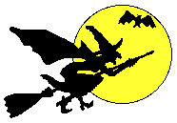

Halloween Chemistry

Demonstration Packet

Dry Ice Demos
- List the chemical compound for dry ice.

- How cold is dry ice?

- Why is it called dry ice?

- Explain the phase changes of dry ice?

- What is the process from question #4 called?

- How does the density of CO₂ compare to the air we breathe? Explain your answer.

- When you drop dry ice in water does a chemical reaction take place? Explain your answer.

Glow Sticks
- Explain the chemistry behind a glow stick by drawing a scientific sketch.
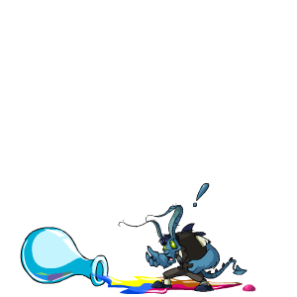

- Explain your drawing with a few sentences.

- List the chemicals found inside a glow stick.

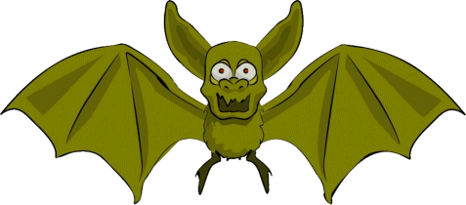
Whoosh Bottle
- What is the chemical in the bottle?

- Draw a picture of what you saw happen.

- Did a chemical reaction take place? If so, write the equation for this reaction.

- Does the above equation follow the Law of Conservation of Mass? If not, balance the equation below:

- Why does the bottle get sucked in when you put your hand over the lid?

Fog Machines
- List the ingredients in fog.

- Is a chemical reaction taking place inside a fog machine? Explain your answer.

Air-Zooka
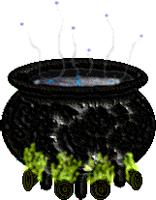
- Does air take up space and does it have mass? How do you know based on this demo?

- What is a vortex and how is it produced?

- Is Mr. B a good aim?

Hot Ice – Sodium Acetate
- What is a solution?

- What is a super-saturated solution?

- Draw a sketch of what you see.
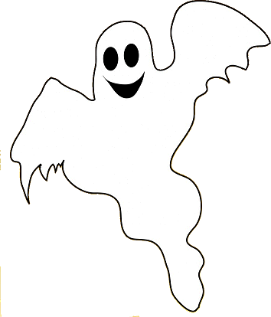

- What is the chemical compound used in this demo?

- What is used to provide a solid nucleation “seed” for the column to form? Why is this seed necessary?

- This is an exothermic reaction. What does that mean?

Magic Pouring Liquid
- Write a few sentences explaining what you saw.

- This demo is a review of acid/base chemistry. What is the indicator in this demonstration?

- What hidden chemical caused the liquid to turn pink? Why?

- What hidden chemical caused the liquid to turn clear? Why?


- Write the chemical equation for this demo.

- Type of chemical reaction = ______________________


Baking Soda Bubbles
- Write the equation provided for this demonstration.

- Is this equation balanced? (check it)

- Is this demo an example of a chemical reaction? Why or why not?

- Which product from the chemical equation caused the candle to go out?

- Why was it possible to pour the gas onto another candle?

- What are the reactants in this demo?

- What are the products in this demo?

Elephant Toothpaste
- How do we commonly use hydrogen peroxide in our lives?

- Why must hydrogen peroxide be stored in a dark container?

- Draw what you saw happen during this demo.

- Write the equation for this demo.

- Is this demo an example of a chemical reaction? Why or why not?

- What are the names of the chemical reactants?

- What are the names of the chemical products?

- Is the leftover foam from this reaction safe to touch? What is it?

- Predict what would have happened if we left the dish soap out of this demonstration.

Think Ink!!
- Write a few sentences explaining what you saw happen.

- What are the chemical equations used to explain this demo?

- List any evidence that you observed that indicates that a chemical reaction had taken place.

Electrolysis of Water
- Write a few sentences explaining what happened.

- Is this demo an example of a chemical reaction? Why or why not?

- Write the equation for the electrolysis of water.

- What type of reaction is this equation?


- Why are there 2 coefficients in this equation?

- Which chemical product went BOOM?

Burning Magnesium
- What chemicals are present in a match?

- Write the equation for the magnesium demo?

- What type of reaction is this?


Exploding Pumpkin
- Write the equation for this demo.

- Is the given equation balanced?

- What type of reaction is this equation?

- Draw a sketch of what you saw.

- Explain why the pumpkin exploded using complete sentences.

- Reflect on what the reactants looked like before the reaction took place. Then, list three observations that you saw in the product that showed evidence for chemical change after the explosion.

Halloween Chemistry

Demonstration Packet

Dry Ice Demos
- List the chemical compound for dry ice.
Carbon Dioxide
- How cold is dry ice?
- 70 deg. C
- Why is it called dry ice?
It does not leave a puddle when it melts…

- Explain the phase changes of dry ice?
It goes from solid to gas (skipping liquid)

- What is the process from question #4 called?
Sublimation

- How does the density of CO₂ compare to the air we breathe? Explain your answer.
More dense (sinks)

- When you drop dry ice in water does a chemical reaction take place? Explain your answer.
No- phase change (still CO2)

Glow Sticks
- Explain the chemistry behind a glow stick by drawing a scientific sketch.
Chemical inside main chamber = phenyl oxalate ester + florescent dye
Chemical inside glass capsule = hydrogen peroxide
RxN is a redox giving energy to florescent dye by passing electrons. This makes the dye glow
Decomposed (which releases energy exciting the dye)

- Explain your drawing with a few sentences.
See Above

- List the chemicals found inside a glow stick above…

Whoosh Bottle
- What is the chemical in the bottle?
Ethanol (like the RxN in the piston of a car)

- Draw a picture of what you saw happen.
Shake around approx. 10 mL of Ethanol in bottle and drop in a match!
Then, cover lid with hand after the flames are done

- Did a chemical reaction take place? If so, write the equation for this reaction.
Yes…CH3CH2OH + O2 → H2O + CO2

- Does the above equation follow the Law of Conservation of Mass? If not, balance the equation below:
NO… CH3CH2OH + 3O2 → 3H2O + 2CO2

- Why does the bottle get sucked in when you put your hand over the lid?
Higher air pressure outside of bottle…

Fog Machines
- List the ingredients in fog.
Glycol + water (kinda like cooking oil)

- Is a chemical reaction taking place inside a fog machine? Explain your answer.
No…phase change liquid → gas

Air-Zooka
- Does air take up space and does it have mass? How do you know based on this demo?
Yes (Nitrogen, Oxygen, CO2, etc…) You can see mass interacting (Newton’s laws)

- What is a vortex and how is it produced?
Spinning/accelerated air

- Is Mr. B a good aim? Of Course!

Hot Ice – Sodium Acetate
- What is a solution?
A mixture of one or more solutes dissolved in a solvent (H2O)

- What is a super-saturated solution?
A specially prepared solution that has more than the maximum amt. of solute dissolved into it. One more seed or nucleation site, will cause the solution to crystalize
- Draw a sketch of what you see.
Mix 1/3 of container of sodium acetate with H2O at near boiling temps. Then cool.
See You Tube Vid ☺

- What is the chemical compound used in this demo?
Sodium Acetate NaCH3COO
- What is used to provide a solid nucleation “seed” for the column to form? Why is this seed necessary?
A solid crystal of Sodium Acetate…this brings the supersaturated mixture out of solution.

- This is an exothermic reaction. What does that mean?
Gives off heat

Magic Pouring Liquid
- Write a few sentences explaining what you saw. 3 BEAKERS
Mix a beaker w a splash of acetic acid CH3COOH (vinegar) and Mostly H2O.
Add 10-12 drops of Phenolphthalein
Beaker 2 – hidden ammonia (turns pink)
Beaker 3 – hidden vinegar (turns COLORLESS)

- This demo is a review of acid/base chemistry. What is the indicator in this demonstration?
Phenolphthalein

- What hidden chemical caused the liquid to turn pink? Why?
Ammonia (base)

- What hidden chemical caused the liquid to turn clear? Why?
Vinegar (acid)
- Write the chemical equation for this demo.
Pink = NH3 + H2O → NH4(+) + OH(-)
Colorless = CH3COOH → CH3COO(-) + H(+)
- Type of chemical reaction = Single Replacement for pink

Baking Soda Bubbles
- Write the equation provided for this demonstration.
Na2CO3 (baking soda) + CH3COOH (vinegar) → CO2 + H2O + CH3COONa (sodium acetate)
- Is this equation balanced? (check it)
Check it!
- Is this demo an example of a chemical reaction? Why or why not?
Yes (new products, EPOCH)

- Which product from the chemical equation caused the candle to go out?
CO2
- Why was it possible to pour the gas onto another candle?
More dense than air

- What are the reactants in this demo?
Na2CO3 (baking soda) + CH3COOH (vinegar)

- What are the products in this demo?
CO2 + H2O + CH3COONa (sodium acetate)

Elephant Toothpaste
- How do we commonly use hydrogen peroxide in our lives?
Cuts/injury (oxygenates)
- Why must hydrogen peroxide be stored in a dark container?
Sunlight will cause a photochemical RxN (product = H2O and O2)

- Draw what you saw happen during this demo.
Dissolve a bunch of KI (potassium iodide) into distilled H2O (use just a small amount of this for RxN)
Use 30% H2O2 + dish soap + food coloring in a graduated cylinder (approx. 80mL total)

- Write the equation for this demo.
H2O2 + KI → H2O + O2 + KI3 + I2
- Is this demo an example of a chemical reaction? Why or why not?
Yes (new products and EPOCH)

- What are the names of the chemical reactants?
Hydrogen Peroxide and Potassium Iodide
- What are the names of the chemical products?
Water, Oxygen, Sodium Iodate and Iodine
- Is the leftover foam from this reaction safe to touch? What is it?
Oxygen Bubbles trapped in dish soap (safe)
- Predict what would have happened if we left the dish soap out of this demonstration.

Think Ink!!
- Write a few sentences explaining what you saw happen.
Solution A (1 ratio) + Soultion B (2 ratio) = Dark Ink Color after 30 sec.

- What are the chemical equations used to explain this demo?
Complicated!! The basics: two reactions occur. 1st reaction produces Iodate (I⁻ ) as a product. The I⁻ competes with iodine (I₂ ) until the first reaction is finished. Then the I₂ wins the battle and reacts with starch → I₂ + Starch = Ink Color

- List any evidence that you observed that indicates that a chemical reaction had taken place.
Color Change → timed RxN (iodine clock reaction w/ starch)

Electrolysis of Water
- Write a few sentences explaining what happened.
Elecrodes give H2O electrons to decompose / break bonds in H2O (kinda)
Really: Sulfuric Acid (H2SO4) looses hydrogen gas in electrodes and is trapped in soap bubbles
HOW TO: Pipette with sulfuric acid and two pins in sides of pipette lead to a battery with alligator clips. Connect battery and this will release the H2 gas into a Petri dish. LIGHT IT UP!

- Is this demo an example of a chemical reaction? Why or why not?
YES (new product that was flammable)

- Write the equation for the electrolysis of water.
2H2O →2H2 + O2

- What type of reaction is this equation?
Decomposition

- Why are there 2 coefficients in this equation?
Cons. Of Mass - must balance equation

- Which chemical product went BOOM?
Hydrogen Gas

Burning Magnesium
- What chemicals are present in a match?
The heads of strike-anywhere matches are composed of two parts, the tip and the base. The tip contains a mixture of phosphorus sesquisulfide and potassium chlorate. Phosphorus sesquisulfide is a highly reactive, non-toxic chemical used in place of white phosphorus. It is easily ignited by the heat of friction against a rough surface. The potassium chlorate supplies the oxygen needed for combustion. The tip also contains powdered glass and other inert filler material to increase the friction and control the burning rate. Animal glue is used to bind the chemicals together, and a small amount of zinc oxide may be added to the tip to give it a whitish color. The base contains many of the same materials as the tip, but has a smaller amount of phosphorus sesquisulfide. It also contains sulfur, rosin, and a small amount of paraffin wax to sustain combustion (red phosphorus). A water-soluble dye may be added to give the base a color such as red or blue.
- Write the equation for the magnesium demo?
2Mg + O2 → 2MgO

- What type of reaction is this? Synthesis

Exploding Pumpkin
- Write the equation for this demo.
CaC2 + 2H2O → Ca(OH)2 + C2H2 (acetylene: flammable gas)
ALSO COMBUSTION: 2C2H2 + 5O2 → 2H2O + 4CO2

- Is the given equation balanced?
Yes
- What type of reaction is this equation?
Double Replacement?
- Draw a sketch of what you saw.

- Explain why the pumpkin exploded using complete sentences.
Flammable Gas build up in pumpkin (C2H2) + Spark! = ☺

- Reflect on what the reactants looked like before the reaction took place. Then, list three observations that you saw in the product that showed evidence for chemical change after the explosion.

Color Change
Odor
Heat
Bubbles

