Name _____________________________ Date ______________________

A STUDY OF ENZYME FUNCTION: LACTOSE INTOLERANCE

BACKGROUND

If you have problems digesting milk, ice cream, yogurt, cheese or other dairy foods, chances are you’re one of the 75% of the world’s population who are “lactose intolerant”. Lactose intolerance is an inability to digest lactose— the sugar found in milk and milk products. It is estimated to affect 8% of people in NZ, with substantially higher rates among Māori, Pacific and southeast Asian peoples.

Lactose is normally broken down by the digestive enzyme lactase, which is produced by the small intestine. Lactose is a disaccharide made of two simple sugars, glucose and galactose. When lactase works properly, it breaks down lactose sugar into glucose and galactose which can then be absorbed through the intestinal lining and used by your body.

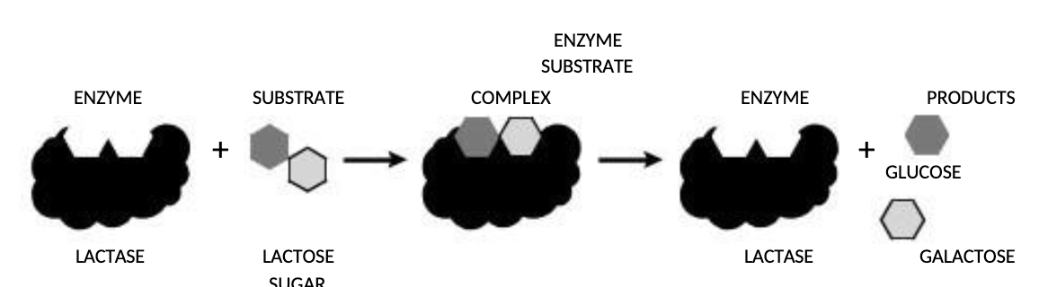

Lactose intolerance is usually caused from a deficiency in lactase — your body produces no enzyme or too little enzyme. When the body does not have enough lactase enzyme, the undigested and unabsorbed lactose sugar is moved into the colon (lower part of your digestive system), where it becomes fermented by intestinal bacteria. The fermentation process produces a lot of gas and causes the unpleasant discomfort of gas bloating, cramps, and diarrhoea. The amount of reaction and discomfort differs among individuals. Some people can have mild symptoms that pass quickly, while others can have severe symptoms that leave them feeling ill for many hours. However, lactose intolerance is not life threatening and you are only affected when you eat foods made from milk.

Interestingly, most people are born with the ability to produce the lactase enzyme and can digest lactose sugar during infancy and early childhood, while drinking mother’s milk. But many lactose intolerant people gradually produced less lactase as they grow older. Although lactose intolerance is more prevalent among certain ethnic groups, all sectors of the population are affected. It is especially common among Asians, Africans, Jews, Native Americans, Inuit (Eskimos), and Hispanics. Many of these cultures, traditionally, do not raise dairy animals and do not use milk as a significant source of protein.

If you have lactose intolerance, you should know about “hidden” sources of lactose. Although milk and foods made from milk are the only natural sources of lactose sugar, lactose is often added to prepared foods. As a result, those people with a very low tolerance for lactose should watch out for foods that contain lactose, even in small amounts. Some so-called “non-dairy” products (powdered coffee creamer and whipped toppings) may include ingredients that are derived from milk, and therefore contain lactose. Lactose is an added (inactive) ingredient in more than 20% of prescription drugs and about 6% of over-the-counter medicines. People with lactose intolerance need to read food labels with care, looking for milk and lactose among the ingredients, but also for such words as: whey curds, dry milk solids, milk by-products, and non-fat dry milk powder. If these contents are listed on a label, the product most likely contains lactose.

Many people who are lactose intolerant avoid dairy foods and foods containing lactose. However, these foods generally do not have to be eliminated from the diet. Dairy products are sources of essential nutrients such as vitamins A and D, protein, riboflavin, calcium, magnesium, and potassium.

To make foods containing lactose easier to digest, natural enzyme supplements can be taken before or with a meal. Supplements such as Lactaid can help make lactose containing foods easier to digest. Lactaid contains the enzyme lactase that has been produced by and isolated from fungal and bacterial cultures. The caplet form of Lactaid is swallowed or chewed before eating dairy products. The drop form of Lactaid is mixed with milk to produce lactose-free milk. When you use any of these supplements, you are eating the digestive enzyme that you normally would be producing.

**To identify whether you are lactose intolerant, try the following test:**

On Day one do not eat any dairy products after 8pm. Then on Day Two, eat a normal breakfast and include a large 12 ounce glass of milk. Over the next 6 hours, keep track of any discomforts, if they occur, and how severe they are. On Day Three, take 3 Lactaid capsules five minutes before your breakfast. Then eat a normal breakfast and include a large 12 ounce glass of milk. If you are lactose intolerant, you will probably notice less, or even none of the discomfort that you experienced on day one.

PROCEDURE

In this lab, you will investigate the action of the enzyme lactase. Specifically, you will be designing a detailed experiment to test the effect of Lactaid on milk. The goal is to understand how Lactaid functions to help people with lactose intolerance and also to understand how enzymes function in general.

1. Read the background information at the beginning of the lab so you understand lactose intolerance, the action of the enzyme lactase and the commercial product, Lactaid.
2. You have just read in the previous section that Lactaid is really the enzyme lactase. And that lactase breaks down (digests) the disaccharide lactose into two smaller sugars: glucose and galactose. LACTOSE 🡪 GLUCOSE + GALACTOSE

BUT, after becoming a biology student, you have been transformed into a sceptical scientist. You are not going to take our word for it, you are going to prove it to yourself! So…you begin to design an experiment to test the effect of Lactaid on milk.

1. Design a controlled experiment that shows …
2. Which types of milk contain lactase
3. That Lactaid does what it claims: help lactose intolerant people by converting milk products

into lactose-free milk products AND

1. If Lactaid’s enzyme (lactase) effectiveness is affected by pH or Temperature.

**Suggested materials:**

Cow’s milk

Soy milk / almond milk / rice milk

Lactaid

Tap water and ice

Distilled water

Hot plate or Bunsen

Test-tubes

Glucose test strips or Benedict’s solution

Waterbath or beaker/tripod/gauze

Acid to change pH

Adapted from

<https://www.coursehero.com/file/70330566/Lactaid-Lab-Lactose-Intolerance-design-your-owndocx/>