Explaining the carbon cycle

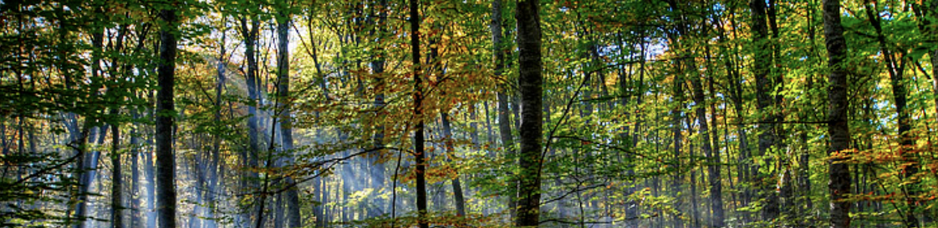

The carbon cycle is nature's way of reusing carbon atoms, which travel from the atmosphere into organisms then into the Earth and then back into the atmosphere over and over again

Carbon is stored

* Mostly in rocks and sediments as carbonates
* in the ocean as carbon dioxide and carbonates
* in the atmosphere as carbon dioxide mostly with some methane
* in living organisms as sugars, proteins and fats

Carbon cycles through these storage reservoirs.

On land, plants absorb carbon as CO2 from the air and together with water they make and store food (sugars mainly) in the process of photosynthesis. Animals absorb carbon in their food as sugars, proteins and fats and this is used to build tissues in their body. Both animals and plants release CO2 from their cells in the process of respiration. When plants and animals die and decay this carbon is released, to the air as CO2 or to the soil, as carbonates. Decomposers also take in carbon in their food and respire.

Living things (eg. fish, seaweed, plankton, crabs) in the ocean make CO2 by respiration. Some CO2 escapes to the atmosphere. Some is used by plant plankton & seaweed when they photosynthesise. The ocean absorbs some carbon dioxide, which in water is converted to carbonate ions. Some organisms absorb carbonate to make their shells or skeleton. The rest sinks to the bottom as sediment – compacted and cemented together this can form limestone. When exposed to sufficient heat and pressure this rock can melt and the CO2 be released back to the atmosphere through volcanic eruptions.

When living things die they decompose and if covered for millions of years they can become fossil fuels (eg coal, petroleum, natural gas). When we burn these fuels for energy, vast amounts of carbon dioxide are released back into the atmosphere.

This excess carbon dioxide changes our climate — increasing global temperatures, causing the ocean to become more acidic, and disrupting the planet’s ecosystems.

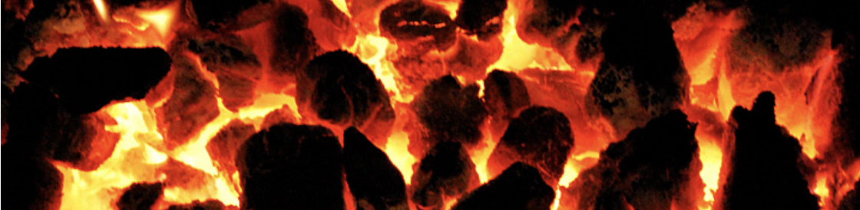

Sources

<https://oceanservice.noaa.gov/facts/carbon-cycle.html#transcript>

<https://earthobservatory.nasa.gov/features/CarbonCycle>