Cells and organelles

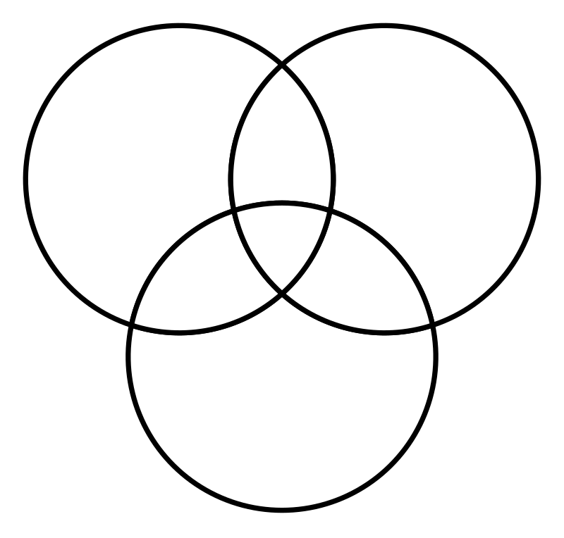

Animal Cell

Prokaryote

Plant Cell

Put these in the correct place

Cell membrane Cell wall Centriole

Chloroplast Cytoplasm DNA

Golgi Lysosome Nucleus

Mitochondria Plasmid Ribosome

Rough ER Smooth ER Central water vacuole

