Practices to conserve water

Farmers can implement several effective practices to preserve soil moisture:

1. Mulching: Applying organic or synthetic mulch on the soil surface helps retain moisture by reducing evaporation, suppressing weeds, and regulating soil temperature.
2. Cover Cropping: Planting cover crops during the off-season protects the soil from erosion, enhances organic matter, and improves moisture retention by maintaining soil structure.
3. Conservation Tillage: Reducing tillage minimizes soil disturbance, helping to maintain soil structure and moisture levels. Techniques like no-till or reduced-till farming can enhance water retention.
4. Rainwater Harvesting: Collecting and storing rainwater for irrigation can supplement water supply and reduce dependency on external sources, helping maintain soil moisture levels during dry periods.

Implementing these practices can significantly improve soil moisture retention and promote sustainable agricultural practices.

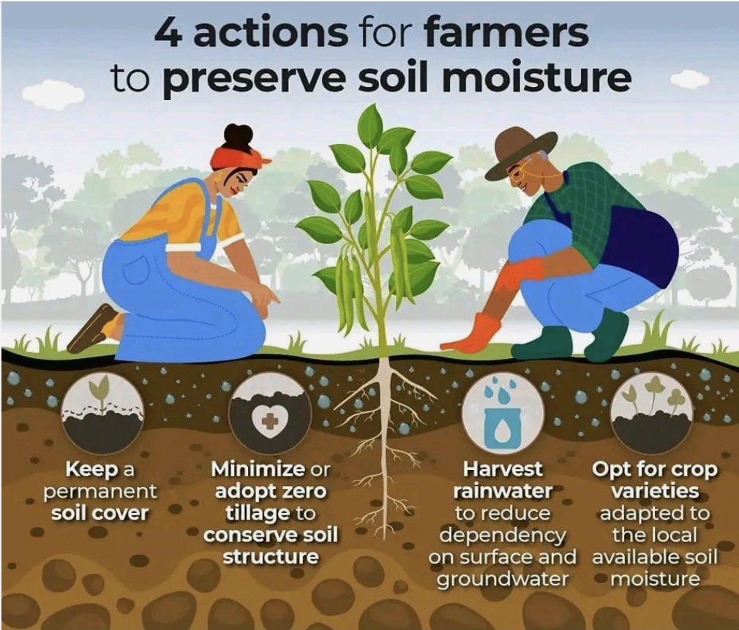

[AgriHarvest Hub](https://www.facebook.com/profile.php?id=100084565680076&__cft__%5b0%5d=AZXy0-iN6E5ZCCwub4m6FqVN4Oz3UuMY3TOtTWES8QrBakqkIP3oxFfXv1BWG5VsMxWkDnZbxkw3mlz8JPZkqdxWN-TpQoyXH9AdVhNTD-wtvkPhU3-HxELW-IVi0L4N-YByvgJ6ZtLJusLjORFapxDOpe9EQd1xE1fGMUbmWqsmWpi7ZvKkZVHaKLydPgop9YY&__tn__=-%5dK-R) -Agriculturist