ENTER THE

JOHN PAUL COLLEGE

SCIENCE FAIR

Open to all Year 7-13 Students

Prizes for year Level Section Winners

Entry to the BOP Science Fair is based on the

School Science Fair

JOHN PAUL COLLEGE

SCIENCE FAIR

As part of their Science Programme, Years 7 through 13 students may present a project in the John Paul College Science Fair.

It is **optional** for other students.

The display and judging of projects will take place during Week 2 of Term 3.

A parents’ evening will be held during that week where you can view the projects.

TYPES OF EXHIBITS:

Category 1: Science Investigation

This category involves doing a scientific investigation. Your teacher

will give you further information on how to carry out this activity.

No more than **two** (2) students per investigation.

Category 2: Science Research Project

(This option is only available to year 7 and 8 students)

This category involves researching some aspect of science and

presenting it in a display form. Your teacher will give you some ideas

on what you could do a research project on.

This is an **INDIVIDUAL** project. ie you must do it on your own.

For these categories a display must be presented. You will be judged on how well you have presented your information.

PRESENTATION GUIDELINES

This is a major **step**. Your entry can only be judged on the information you can communicate – so the way you set out the display board can determine your results.

**MAKE SURE:** Your display is free standing

* You have no valuable items on your display.
* Your display shows the steps you took in your investigation – in order.
* There are no spelling mistakes or errors.
* Nobody will be offended by any of the content.
* Any graphics or 3-D props are relevant.
* The information is clear and easy to read from a distance i.e. 14 pt or bigger and a clear font e.g. Times, Arial, Garamond.
* All extra material/models/support information fits inside your display area.

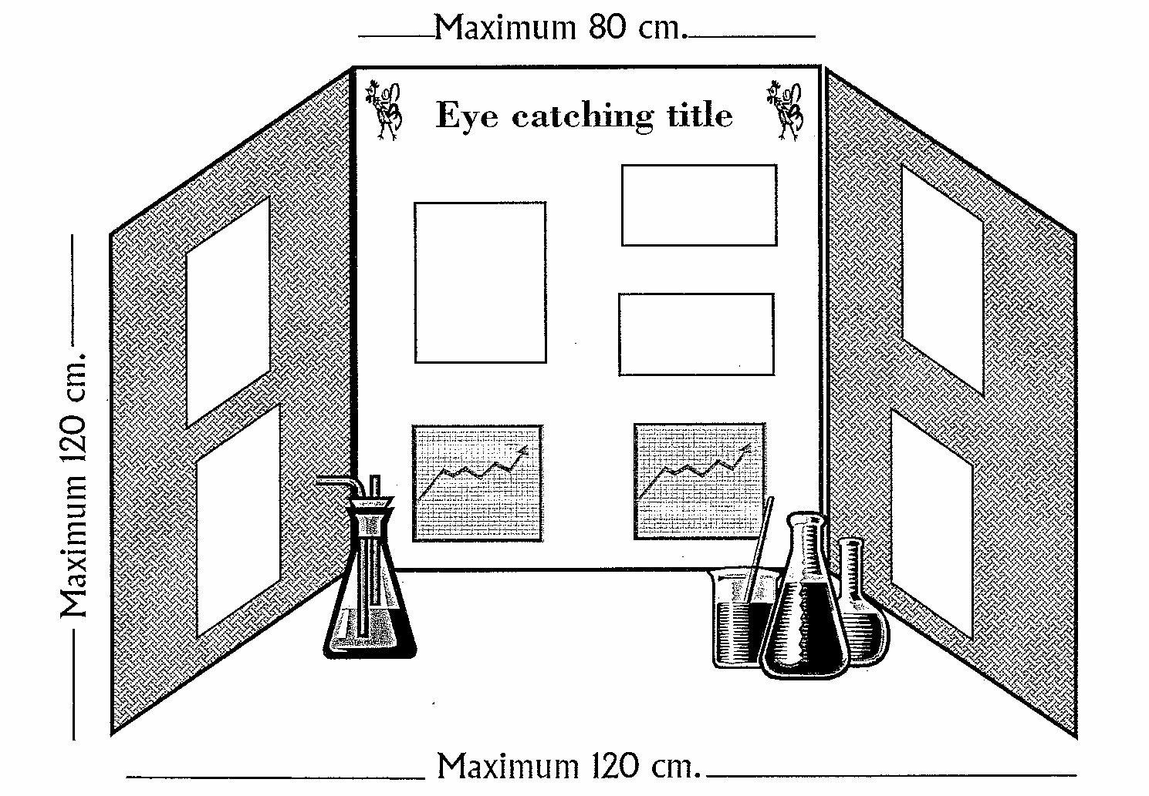

PLANNING YOUR SCIENTIFIC INVESTIGATION

|  |  |
| --- | --- |
| **Question:** This is what I am trying to find out | |
| **Existing Ideas:** This is what I already know which may help | |
| **Hypothesis:** This is what I predict will happen? | |
| **Method:** Here are the steps I will follow? | **Constants:** These are the things I need to keep the same.  **Variable:** This is the one thing  I will change. |
| **Measurements:** This is what I am going to observe and measure? | |
| **Organiser:** This is how I will organise my results? | |
| **Equipment:** This is the equipment I will need to carry out my investigation? | |

THE SCIENTIFIC INVESTIGATION PROCESS

**QUESTION**

Questions need to be **specific**.

What is meant by best, longest, strongest, driest…

Which?

What?

**HYPOTHESIS**

What do you think

**may** happen?

**Predict** the answer to your question

Record everything.

How, when what?

Have you run at least 3 tests??

Is your sample size more than 6?

**Plan** how you will find your answer.

Have you controlled all variables?

What is your time scale?

What equipment will you need?

**TEST**

**RECORDS AND**

**RESULTS**

Decide on an organiser that will present your results clearly and effectively

Observations, research, measurements,

surveys, experiments

Analysis of graphs.

Interpretations

What does it all mean?

What next?

Have you found the answer?

Do you need to add some other controls?

**DISCUSSION**

**OF RESULTS**

In what ways do your results support/refute your hypothesis?

Positive

Minus

Interesting

Improvements

Questions

**CONCLUSION**

**WRITING AN EXPERIMENT**

A well written experiment should show the reader how you:

* Came up with a question from something you were interested in.
* Thought about an answer and a way of finding this out.
* Carried out your investigation and interpreted your results.
* Reflected upon the experimental process and what you learnt.

All the main parts of an experiment should be separated with a sub-heading and recorded in order.

**INTRODUCTION (What you already know about your topic)**

This gives the reader some background information to your topic and the reasons why you may have chosen your question. It is set out in paragraphs and is brief but specific.

**AIM (What you want to find out)**

This tells the reader what you want to find out through your experiment. It is your question.

**HYPOTHESIS (What you predict will happen)**

This tells the reader what you think will happen. It is usually only two sentences long.

e.g. If I …………………………… then ………………………….. will happen.

**EQUIPMENT (What you have used to carry out your experiment)**

This is the list that gives the reader an idea of all the resources you have used. Remember to include people.

**METHOD (What have you done)**

This is a form or procedural writing that tells the reader the steps you have undertaken to carry out the investigation, what you have measured and how.

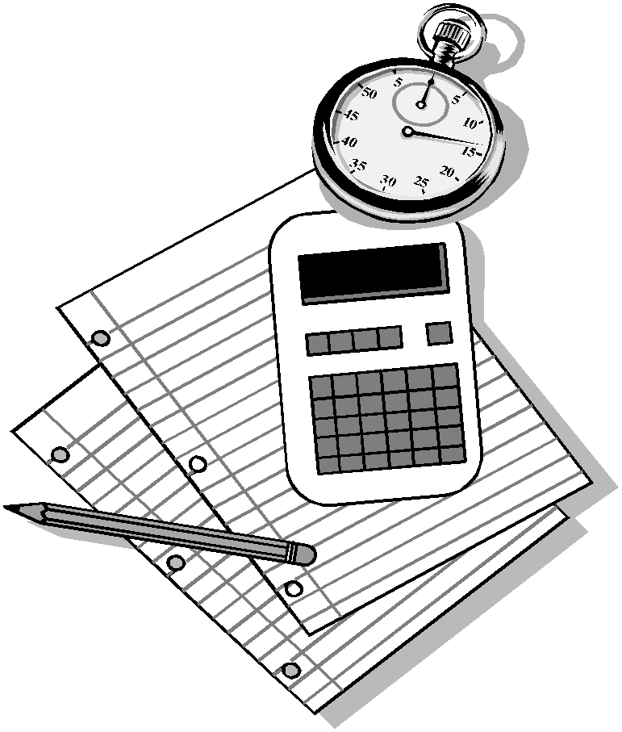

It should:

* Give the instructions to your experiment in order.
* Have a verb – such as mix, place, cut … at the start of each instruction.
* Have a line between each step.
* Have precise and clear instructions.
* Only contain factual and necessary words.
* Have each instruction numbered.

**RECORDS AND RESULTS (The raw data from your investigation)**

Usually shown as a table of raw data, samples, photos, a video, a brief description, or a diagram or sketch

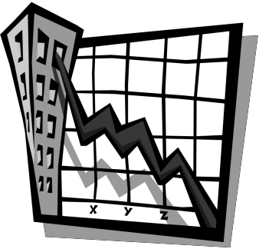**DISCUSSION OF YOUR RESULTS (An analysis of your results)**

This is usually shown as graphs and brief explanations. It explains the raw data presented in your results.

Graphs must have:

* An even scale
* A title
* Precise, clear explanations
* A key

**CONCLUSION (Was your hypothesis right? If so, why? If not, why? Could you have done anything better? How could your improve it for next time?)**

This tells the reader if your hypothesis was right, whether your experiment was carried out

fairly and if you have any new queries.

It should:

* Have a summary and introduction.
* Be set out in clear paragraphs, each one expanding on an idea.
* Be written in precise clear language.
* State clearly your opinion on how you carried out the experimental process and what you have learnt.



**SOME IMPORTANT DESIGN INFORMATION**

* **Avoid** repetition – Your design needs to be innovative, to look for needs or for opportunities what will make jobs, etc easier.
* Set a plan (long or short) and map it out.
* A **Log Book is essential;** include all problems encountered and solutions found.
* Test the product – yourself and in the market place at least 3 times. Record the

results.

* Cost and analysis is important.
* Include a **bibliography** and **acknowledgements.**
* Presentation (cards) is the final step – all other work needs to be completed first.
* It is a **2 –3 month** project – not 2 weeks.

|  |  |
| --- | --- |
| Science – Judging Criteria | Value |
| **Oral Communication:**  Ability to discuss findings and the significance of these; ability to explain scientific principles involved. | 10% |
| **Scientific Process and Background:**  Clear aim/hypothesis carried through; method, accurate experimentation and includes appropriate data; results clear, accurate and include appropriate data; discussion and analysis of results; conclusions in line with aim/hypothesis; results are interpreted and discussed. | 50% |
| **Technical Skills:**  Design of the experiment and the use of apparatus and materials. | 10% |
| **Originality:**  Imaginative/Creative ideas; New/Unusual application in science. | 10% |
| **Presentation of Display:**  Colour/Form; Clarity; Graphics; Innovative appeal. | 10% |
| **Log Book:**  Authentic ongoing record showing raw data/field data; supporting documentation, bibliography, and acknowledgements included. | 10% |

**SOME SCIENCE FAIR IDEAS**

**PLANTS**

What factors affect seed germination?

What amounts of light promote algae growth in a fish tank?

What medium is best for seeds to sprout?

How does temperature affect the water uptake of celery plants?

Which parts of a bean are needed to grow a healthy bean plant

How are transpiration rates affected by the measured area of a leaf?

Can the lifespan of cut flowers be extended?

**ANIMALS**

How does the size affect breathing rates of tropical fish?

How does temperature impact the activity of ants?

How does time of day affect the problem solving ability of a hamster in a maze

How does surface affect the travel rate of a caterpillar?

What foods do worms prefer in a compost bin?

What conditions attract the most insect pests (mosquitoes, flies etc)

What natural products are best at repelling insects?

How does moisture affect the tunnelling ability of ants?

How do laws/policies on deer affect deer populations?

Are natural sponges more absorbent than synthetic sponges?

**HEALTH/HUMAN BODY**

What conditions impact productivity while doing homework?

How does smell affect taste?

Which brand of skin moisturizer lasts the longest?

Do reflexes change with age?

How do different types of movement affect human heart rate?

What conditions improve short term memory?

How does air moisture affect healing time of a stuffy nose?

Does loud music affect driving reaction time?

**MICRO ORGANISMS**

What is the best way to reduce odour in shoes?

At what temperature does yoghurt culture grow best?

How does the location of water samples affect the number of micro-organisms observed?

What conditions keep bread mould from growing on bread?

How does bacteria in the mouth of a human, dog, cat compare?

What conditions improve bread yeast growth?

Does medicated soap have a greater effect on bacteria?

**ENVIRONMENT**

Does recycled paper decompose more quickly than non-recycled paper?

Which type of inside window covering is best for saving energy?

How does oil affect the growth of aquatic plants?

How does acid rain affect plant growth?

Which conditions will result in more people recycling?

What strategies are best for increasing petrol mileage?

Is natural light better for concentrating than artificial light?

**GEOLOGY**

What type of soil can hold the most water?

Which conditions stop erosion the best?

How do differe3nt liquid solutions with varying pH levels affect rocks?

What conditions are best for making the tallest sandcastle?

What factors are best to grow sugar crystals?

Which structure of a house is best at withstanding earthquakes?

What is the best way to remove deposits from a copper coin?

**CHEMISTRY**

Which egg substitutes are best for different recipes?

How does temperature affect the rate of reaction?

How does particle size affect the rate of reaction?

How does temperature affect the brewing of tea?

Which detergent is best for removing stains?

What conditions are best to stop lemonade from losing its fizz?

**WEATHER**

How does a surface affect the rate that it is warmed?

Does the sun heat salt and freshwater at the same rate?

How does topography affect wind speed?

How does air temperature affect the rate of evaporation?

How does weather affect mood?

**ENERGY/FORCE**

What type of paper makes the best paper aeroplane  
How does mass affect a pendulum swing?

What is the best shock absorber for dropping an egg?

Which type of ball bounces the highest?

How does temperature affect a magnet’s strength?

What materials conduct the best heat?

Which conditions produce the best echo?

How do different surfaces affect friction?

How do pulleys affect the amount of mass that can be lifted?

Which conditions make for the fastest speed boat?

Why do cars skid?

**MATTER**

Which paper towel absorbs the fastest?

How does temperature affect air pressure in a tyre?

How does a container’s size and shape affect evaporation rate?

Which type of microwave popcorn pops the best?

How does the type of liquid impact the freezing time of liquids?

How does density affect the buoyancy of objects?

What is the best way to remove wrinkles from fabric?

How does temperature affect the drying time of paint?

Which brand of paper towel is strongest when wet?

**HELPFUL WEB SITES**

<http://www.sciencebob.com/sciencefair/ideas.php>

<http://www.education.com/science-fair/>

<http://www.sciencekids.co.nz/projects.html>

<https://www.googlesciencefair.com/springboard/en/>

<http://sciencefair.math.iit.edu/projects/>

C:\Users\monique.lowe\AppData\Local\Microsoft\Windows\Temporary Internet Files\Content.IE5\CBTSEK4K\MC900439851[1].wmf