Science & Technology Fair
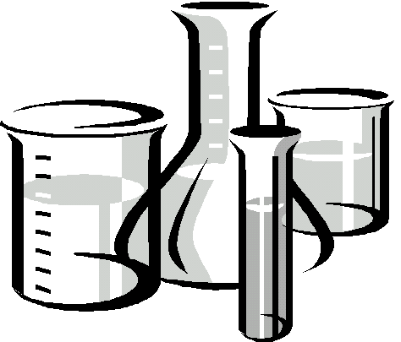

SCIENCE INVESTIGATION

Name(s): _____________________________
_____________________________
Form: _____________________________
Due date: _____________________________

Science vs Technology
Your project can be either a science investigation or a technology project.
What’s the difference?
Good Science usually involves the development of a hypothesis or a question relating to how something might work and carrying out a fair test to find an answer
- You will have to research your topic to find out about Science ideas relating to your question
- You will have to test your idea by carrying out a fair test investigation and collecting data.
- You will need to repeat your investigation a few times to make sure your results are reliable
- You will then interpret your results and what they mean in relation to your hypothesis/question

Good technology usually involves the design and creation of a solution to a real problem.
- You need to identify a real problem that needs a solution
- You will have to find out about (research) ideas relating to the problem you have identified
- You will need to come up with a range of possible solutions, then choose the best idea to make and test
- You will need to test your solution (e.g. with a fair test experiment or survey) to evaluate how well it works to solve the problem
- You may need to refine your solution and retest it to improve its performance

Here are some examples of things which are NOT good science nor good technology because they do NOT involve either of the processes described above:
model-making: taking an existing design for a device and building it
e.g. making a model volcano
surveys: asking people for their opinions about something and collating the results
eating: selecting a range of foods and eating them to decide which one tastes the best
playing: following an existing method to see if you can carry out an already well-known experiment successfully

Science investigation flow chart
Decide on a topic
➲
Determine an aim/testable question
➲
Make a prediction/hypothesis
Determine  variables | Independent variable
Determine  variables | Dependent variable
Determine  variables | Fixed / controlled variables
Make a plan / method
➲
Collect all equipment needed
➲
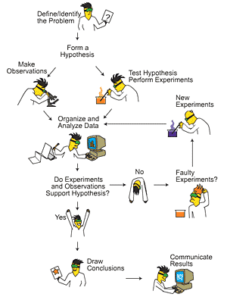
Carry out experiment,
including repeats
➲
Collect data
➲
Process data
➲
Make conclusion
➲
Research and
write discussion
➲
Presentation

Technology project flow chart
Identify and describe a need / opportunity / problem
➲
Set a goal for what the solution needs to achieve
➲
Generate possible solutions
➲
Select one solution based on:
- the available resources
- your skill
- the time available
➲
Design and construct the solution
➲
Test the solution |  |  |  | Modify it
➲ 
Evaluate the solution in relation to your goal |  | Does it achieve the goal? |  |  | No |  |  | Yes |  | No
 |  |  |  |  |  |  |  |  
 |  |  |  |  |  |  |  | Can it be modified?
Evaluate the solution in relation to your goal |  | ➲
Evaluate the solution in relation to your goal |  | Yes |  |  |  |  | 
➲
Write report of entire process
➲
Presentation
Note: This booklet is designed to help develop and carry out a Science investigation.
Keeping a log book

All good Science & Technology Fair projects are accompanied by a log book. This could be an exercise book or a notebook . Alternatively, you could use the pages provided at the end of this booklet (p28-36)

Keeping a log book is an ongoing endeavour. The logbook gets submitted and displayed with your Science & Technology Fair board.

Log books are:
A diary | - to keep track of your thought and ideas  - to plan how you will use your time
A workbook | - to record your method, mistakes, improvements  - to record the things you need to do and things you plan to do
A notebook | - to record notes from conversations with teachers, consultants, experts and ideas from friends and family
A research book | - to record information that you find out from books, internet, libraries  - to record where your research came from
A record book | - to write all your raw results from your trials, your final experiments, surveys and tests
A draft book | - to write out drafts of all your final notes and then edit them

Log books are not:
- always neat and tidy
- written at the end of your project

A suggested template for a logbook is shown below.
Today’s date: _______________________

My/Our goal for today:

What I/we did today:

What worked well (my/our successes):

What did not work so well (the problems):

Any changes I/we had to make to my/our original plan:

Why I/we had to make those changes:

What I/we need to do next time:

Milestones: Science investigation
Use this page to keep track of your progress throughout your investigation.

Date | Page | Milestone | Started | Finished!
 | 8 | Brainstorm and/or research ideas | ◻ | ◻
 | 8 | Decide on a topic | ◻ | ◻
 | 9 | Write an aim for topic | ◻ | ◻
 | 9 | Make a prediction | ◻ | ◻
 | 10-11 | Work out the variables | ◻ | ◻
 | 12-13 | Write a draft method | ◻ | ◻
 | 14 | List equipment needed | ◻ | ◻
 | 14 | Organise equipment needed | ◻ | ◻
 | 15 | Carry out experiment | ◻ | ◻
 | 16 | Record results | ◻ | ◻
 | 16-18 | Process data: calculate averages, draw graphs | ◻ | ◻
 | 19 | Make conclusions based on your results | ◻ | ◻
 | 20 | Discussions: Research science relating to results | ◻ | ◻
 | 21 | Evaluate your investigation
 | 22 | Presentation: Typing and printing
 | 9 | - Aim and/or Hypothesis | ◻ | ◻
 | 9 | - Introduction (optional) | ◻ | ◻
 | 10-11 | - Variables | ◻ | ◻
 | 12-13 | - Final Method (with numbered steps) | ◻ | ◻
 | 16 | - Results table | ◻ | ◻
 | 18 | - Graph(s) | ◻ | ◻
 | 19 | - Conclusion | ◻ | ◻
 | 20 | - Discussion | ◻ | ◻
 | 7 | - References and acknowledgements | ◻ | ◻
 | 22 | Get Science & Technology Fair board | ◻ | ◻
 | 22 | Decorate board (AT HOME) | ◻ | ◻
 | 23 | Put board together in logical order | ◻ | ◻
 | 24 | Complete self-assessment of project | ◻ | ◻
Using the computers
Your teacher will establish a method for monitoring computer access and use with the class. You are expected to follow this procedure or else your computer access may be revoked.

As there are several students all wishing to use computers for the same reason, and you may be unsupervised, you are asked to follow these guidelines:
- Return to class at least 10 minutes before the end of the period to show and stow your work safely.
- Work with your partner on the same computer (unless there are plenty of spare ones).
- Obey the rules of the computer labs regarding food, drink and behaviour.
- Stick to the tasks you need to get done – this is NOT a good time to get banned from the internet.
- Do NOT vandalise the equipment – this could result in unsupervised computer access being denied to everyone doing Science Fair!
- Report any vandalism of equipment you witness.

Saving your work
You must save your work regularly and make sure it is saved in such a way that you can find it again. Make sure you save it in your own directory. Check with the teacher if you are unsure how to do this. Do NOT rely on X files as the only place for your work because it is highly likely to get deleted.
Also make sure the name you give your file is very descriptive and can be easily retrieved.
A good file name: Jessie-and-Hannah-9RL-Science-fair.doc
A bad file name: science fair.doc

When to print
Print your work at the end of each computer session just in case your files get lost. Unless you are printing the final, final, final copy, then print in black and white. You may also need to do this to prove to your teacher the work that you have done.

Working with a partner
One of the major issues with working on computers is what to do when one partner is absent and the other needs to work on the file. This issue is not easily solved.
One suggestion is to end each session by saving your work first on your personal area, then onto X files, then log out. Your partner can then log in, immediately collect the file from X files, and save it onto their personal area too.

Tips to save on your printing costs
- print all draft versions in normal sized font
- print all the text in black and white
- put all your headings on the same page(s) if you want to print them in colour so that you only have to print a few pages

DO NOT PRINT ANYTHING IN COLOUR UNTIL YOUR FINAL
PROOF-READ REPORT IS READY TO PUT ONTO YOUR BOARD
If you print too early, chances are you will need to make changes / lose it / accidentally
crumple it. Save your $$$ and only print in colour when you’re completely ready!
References used
Record any resources you use here and/or on the relevant pages in this booklet.
Books
Title | Author/Editor | Publisher | Year | Page(s)

Websites
URL | Date  seen | Author of page (if any)

People
Name of person | Their position e.g. teacher, DOC worker, university lecturer | Date spoken to
Topics
Brainstorm any ideas you have about what topics you could do it on this page.
If you’re stuck, use the books and internet to help you find some.

Write the topic you have decided on into this box.

Aim
This is where you state what you want to find out or to investigate.
e.g. To find out how temperature affects the speed at which crystals grow.

Why did you choose to do this for your aim? This may form part of the Introduction of your final report. It should detail how what you are trying to find out could be useful.

Prediction/Hypothesis
What do you think you are going to find out?
e.g. We think that crystals will grow faster at warmer temperatures

Variables
The independent variable
This is the variable that you will change deliberately in your experiment
e.g. The temperature at which the crystals are left to grow

What is the independent variable for your experiment?

You also need to decide on a suitable range for your independent variable. A minimum of 3 different values are needed
e.g. Crystals will be left to grow at 0°C, 20°C and 40°C

What is a suitable range for your independent variable?

The dependent variable
This is the variable you will measure in order to collect your results.
e.g. The rate at which crystals form

What will you measure to collect your results? Be specific!

Collecting your data will usually involve the use of one or more measuring instruments such as stopwatches, scales, thermometers, rulers etc
e.g. After 3 days, the mass of crystals formed will be measured using scales

How will you collect your results and what will you use to do it? Be specific!

Variables
The controlled variables
These are all the things that could affect your results that you will need to keep the same in order to make sure your experiment is a fair test. You need to identify as many of these variables as you can and work out how you are going to keep each of them the same.
e.g. The concentration of the solution used to form crystals will be kept the same by mixing up a large batch and using some of this in every trial
e.g. The amount of solution used in each trial will be kept the same by measuring 50mL of solution using a measuring cylinder.

Identify the variables you need to control and describe how you will keep them the same.

Controlled variable | How you will keep this variable the same
Draft method
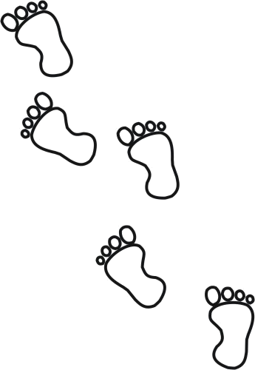
- Write a numbered step-by-step draft of what you will do to carry out your investigation.
- Use a labelled diagram to show how to set up any equipment.
- Try to limit each step to 1-2 lines of text.
- Include the amounts of materials and pieces of equipment as they are needed / used.
- Include how you will change the independent variable, measure the dependent variable AND control all the other variables.

If you make mistakes, then write a new method on refill and glue it in over the top.

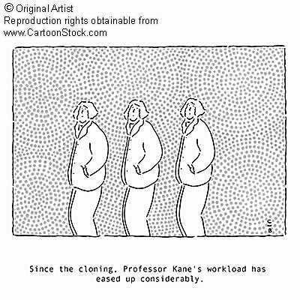
Repeats
You need to carry your entire experiment out more than once. If your method is sound and your results are accurate, you should be able to get similar results by carrying out the experiment more than once.
How many times will you repeat your experiment? Be realistic!

Bear in mind that repeats are often all carried out at the same time, and this may mean you need more equipment.

Changes to your method
As you carry out your experiment, record any changes to your method below.

Equipment and materials
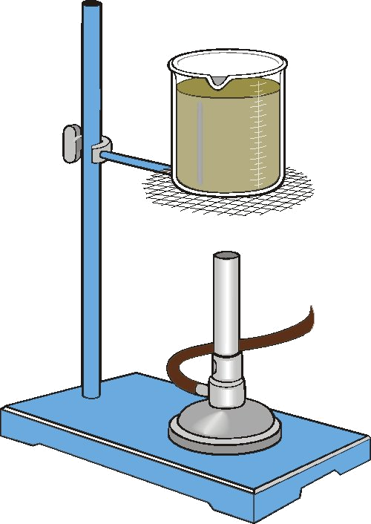
You need to work out exactly what you will need to carry out this investigation.
For each item you name, you also need to think about where you are going to get this equipment from. Standard lab equipment will be available, although check with your teacher to avoid clashes with other groups.
Some materials may cost you money to obtain. You need to work out in your group who is responsible for getting this and how you will share costs.
You may need to change your method to suit what you can get.
What do you need? | How many of this item do you need? | Where will you get the item(s) from? | Who is responsible for getting the item(s)?
Remember to record any changes you make to the equipment you use as you go!
Carrying out your experiment
Remember to:
- record any changes you made to your method on your draft or in the place provided below the draft method.
- record any changes to the equipment you use
- take photos of your investigation
- do as many repeats as you have time and equipment for
- record any problems you have encountered and the solutions you came up with
- do your best to control any variable which could make your experiment a unfair test
- repeat any trials you suspect might not have been fair
- repeat any trials that gave you an odd result, just to be sure
- think of a catchy title for your project as you go

At school:
If there’s any equipment you need to buy or bring from home, make sure you do so on the right days.
If your partner is depending on you to bring stuff in for your project, then don’t let them down!
If you are absent from school for any reason, make sure you tell your partner in time for them to make other arrangements, or else send the materials in to them with another student.

At home:
The Science department is responsible for all projects. If you intend to or have to carry out the project at home, then we need an acknowledgement that your parents or caregivers have agreed to this and will vouch for the safety and authenticity of the work. If this isn’t possible, then you can’t do a home-based project.
Get a parent/caregiver to complete and sign the form below.
You will still be expected to be doing work during science lessons
- the written work for your report
- research needed to explain your results in the Discussion
- homework for other subjects during science class to make up for the time you spend at home on your project.

I, _______________________, give permission for ____________________ to carry out their Science fair project at my home and confirm that I will verify the authenticity of the work and monitor any safety aspects.
Signed: ______________________________________

Results
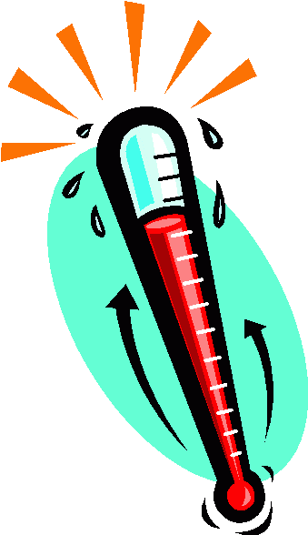
A results table should look similar to the one shown below:
dependent variable goes here
unit
independent variable goes here
unit

Temperature of solution (°C) | Mass of crystals formed in 3 days (g)
Temperature of solution (°C) | Trial 1 | Trial 2 | Trial 3 | Average

Things to note:
- It is not enough to just put things like “temperature” and “time” in the column headings. Temperature of what? Time for what to happen?
- Always put units in the headings. Never put units in the body of the table.
- Trial is spelt t-r-i-a-l. A trail is something you walk along in the bush.
- See Processing for how to calculate and check your averages.

If you make mistakes or this table isn’t suitable for you, then rule up a new
one on blank paper and glue it in over the top. Be sure to follow this template!

( ) | ( )
( ) | Trial 1 | Trial 2 | Trial 3 | Average

To prepare your results table for printing AND to make graphs, use Excel.

Get help from someone else if you have trouble setting up your rows and columns
Processing
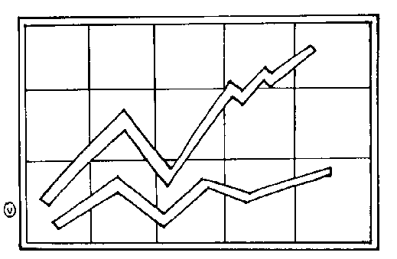
Averaging
CAUTION: If you recorded times in minutes and seconds (or hours and minutes) as your dependent variable, then you need to convert it to seconds (or minutes) BEFORE you average.

Step | Example
- Add together the numbers you recorded for your data and PRESS EQUALS [=] | 2.1, 1.7, 1.8 added together give 5.6
- Divide that total by the number of results you had | had three results, so 5.6 ÷ 3= 1.86666667
- Round to the same number of decimal places as your data | 1.9
- Repeat your calculation to check your answer | 2.1 + 1.7 + 1.8 = 5.6  ➔ 5.6 ÷ 3= 1.86666667  ➔ round to 1.9
- Look at your data again – your average should be somewhere between your highest number and your lowest number. | 1.9 is higher than 1.7 and lower than 2.1 so it is probably the correct average

Graphing
What type of graph?
For this, you need to look at your independent variable:
- If the independent variable is given in words (e.g. golf ball, tennis ball, squash ball) then you will need to draw a bar graph
- If the independent variable is in numbers (e.g. 20°C, 40°C, 60°C) then you will usually need to draw a line graph.

Which way around?
The second step is making sure you have the data the right way around.
- The independent variable always goes along the bottom axis (first column of results table)
- The dependent variable always goes up the side axis (averages column from results table)
To label your graph axes, simply use the headings from your results table, including units.

Using a computer
You are recommended to do all your graphing using Excel. Check with your teacher how to do this if you’re unsure. Your results will need to be put into Excel in the correct format.
If you still can’t figure out how to get a graph drawn by a computer, then draw it yourself using graph paper.

Writing a good title
A good title is one that says exactly what the graph is showing the viewer. It is usually quite similar to the aim i.e. the aim with the words “To find out” taken off the beginning.

Important: only graph the averages!!!
Graph planning
Use this page to plan what your graph should look like. USE PENCIL!!!

Conclusion
Here is where you state what it was you actually found out in words.
- Refer to your averages and your graph. Summarise the general pattern they are showing. DO NOT JUST RESTATE THE RESULTS IN SENTENCES!

- Refer to your aim and answer the question it posed.

- Refer to your prediction/hypothesis – were you correct or not? Rephrase your prediction to describe what you actually found out.

Combine your answers to the above into one paragraph to form a Conclusion

Discussion
This should include the science ideas that explain the results and suggest uses for the answers your investigation has produced
- You will probably have to do some more research to find out about these.
- Remember to record your references in the reference list.
- Try to rewrite information you find into your own words and make it apply directly to the your investigation.
- If your research suggests your investigation has come to an inaccurate conclusion, be honest about this.

If you make mistakes, then write a new method on refill and glue it in over the top.
Evaluation
How well did your experiment go?

Are your results reliable? Why/Why not?

Do you think your experiment was a fair test? Why/Why not?

How you could have improved your investigation?

Presentation
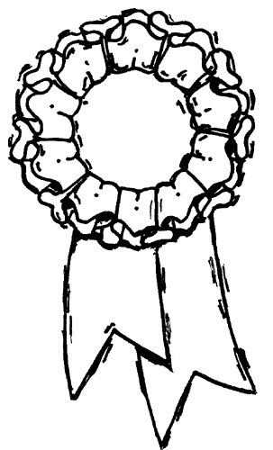
Science fair boards
You will have to buy or provide a science fair board. New ones are available from school. Make sure you clearly name both parts to the board and store them carefully till needed.
The maximum size of the project is to be 1.2m wide by 0.75 m deep by 1m high.

Decorating your board
- If you wish to paint or colour the background of your board, be aware that you will NOT be allowed to do this at school and must take it home.
- You will NOT be given permission to use any Art or Tech department materials and the Art department are fully aware of this.
- Any spray paint brought to school will be confiscated.

Available materials
The Science department will provide you with:
- a maximum of 6 pieces of coloured paper | Neither of these are large enough to cover a science fair board.  Cut them into strips and using them as borders around black and white printed work.  Only take what you need and return any unused pieces dry and uncrumpled.
- a single piece of black paper
- PVA glue | Everything stuck onto a board using PVA goes wrinkly and looks horrible. Glue sticks are far better. Bring your own.

Content
Check that you have something for each section of your investigation (see Order of the report below). Give brief summaries of each stage only.
Extra detail on any section can be included as part of the logbook.

Printing your report
Once your draft version has been checked by the teacher, it is time to prepare your report for printing. Here are a few hints for producing a report that looks good and fulfils its purpose well.
Choose a font size that is big enough to read without leaning into the board. Usually:
- 16-20 point for the text
- 22-30 point for headings
- 100+ point for the title
Choose a font style that is clear and easy to read. Illegible, fancy fonts will lose you marks.
Good: 1: Collect a test tube rack and 9 test tubes.
Bad: 1: Collect a test tube rack and 9 test tubes.
Print your graphs to fill a full A4 page. Please do NOT make the background of your graph highly coloured as this uses up a lot of ink plus it distracts from the pattern the graph is supposed to show.
Colours
Choose your colours wisely. Your project will look more professional if you stick to 1-2 bold and complementary colours rather than try to incorporate a wide range of colours. Have a look at some projects from previous years to see what works and what doesn’t.

You are charged per page of colour printing – make the most of each page by:
- Putting all your headings onto one or two pages and printing them at once. These can later be cut out and stuck at the top of each section.
CHECK THE SPELLING OF THE HEADINGS BEFORE YOU PRINT!
- Putting all the images you want to print on the same page. If you don’t have many, consider sharing costs with another student by putting theirs on your page too.

Order of the report
Just like your home address, a scientific report has a particular order in which information should be presented.
Your science fair board usually has three panels. Lay your report out on the board by starting from the top left and laying your work out from top to bottom on each panel. An example of a complete layout could be:

AIM / HYPOTHESIS  INTRODUCTION  VARIABLES  METHOD  EQUIPMENT | PROJECT TITLE | CONCLUSION  DISCUSSION  EVALUATION  REFERENCES
AIM / HYPOTHESIS  INTRODUCTION  VARIABLES  METHOD  EQUIPMENT | RESULTS  (table, graph, photos) | CONCLUSION  DISCUSSION  EVALUATION  REFERENCES

Layout
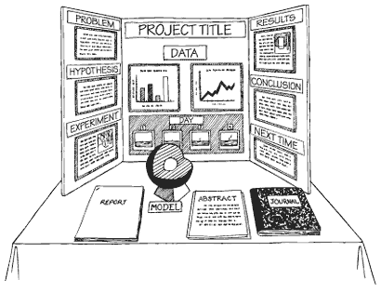
Lay each piece of text on the board so that it is horizontal rather than at a jaunty angle. A range of angles not only looks messy, it makes it harder to read.

Try not to clutter your board up with too much detail – be selective about which photos to use and how you present your results. One well-designed graph can say much more than lots of tiny graphs. Put any extra detail into the logbook.

Do NOT spend time making your board “pretty” unless you have finished ALL the other requirements first. Presentation is only worth 4 out of 41 marks whereas the scientific content is worth 32!
Self-assessment
The following are the judging criteria for science fair projects. Check these as you work through your project and put together your presentation. When you have finished, assess your project using this chart to give yourself a final score and answer the evalutation questions.

Aim and introduction
Title appropriate | 0 | 1
Clear aim | 0 | 1
Clear hypothesis | 0 | 1
Puts problem into bigger picture | 0 | 1 | 2 | 3
Method
Method appropriate for testing aim | 0 | 1
Steps well explained and in a logical sequence | 0 | 1 | 2 | 3
Data obtained with care | 0 | 1
Repeated observations | 0 | 1
Results
Data matches the method | 0 | 1
Processing appropriate to the data and the level of the student | 0 | 1
Correct appropriate tables and graphs – units, titles, legend | 0 | 1 | 2 | 3
Correct interpretation of the results | 0 | 1
identifies trends in the results | 0 | 1
Conclusion and discussion
Link back to aim or hypothesis | 0 | 1
Evaluation of the method and results | 0 | 1 | 2 | 3
Explanation of the results (science ideas) | 0 | 1 | 2 | 3
Relevance of the results to the real world | 0 | 1 | 2 | 3
Thoroughness
Clearly identifies the problem and works through steps to solve the problem | 0 | 1 | 2 | 3
Logbook | 0 | 1
Acknowledgements | 0 | 1
Originality
Shows imagination in choice of topic, approach or product | 0 | 1 | 2 | 3
Presentation
Easy to read – font type and size, colour | 0 | 1
Exhibit attracts attention | 0 | 1
Sequence of ideas is logical | 0 | 1
Appropriate illustrations or display | 0 | 1
TOTAL | / 41

What did you enjoy the most about your project | How could you have improved your project?

Crossword
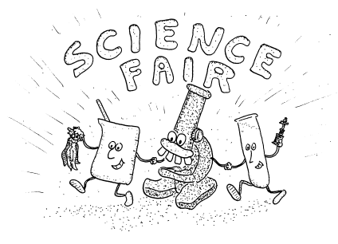
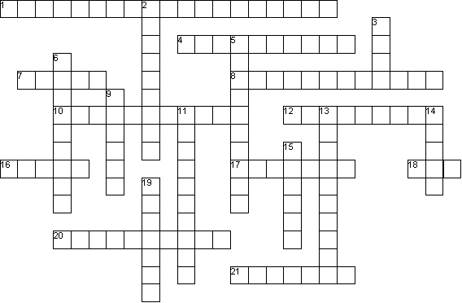



Across
1. These are the things that you must keep the same during your experiment
4. Developing a device or technique to meet a need or solve a problem
7. A way of displaying your results to show the pattern
8. Putting together your final Science Fair board
10. This variable is the one that you will change during your investigation to test your prediction
12. This variable is the one that you will measure to collect your results
16. You should rule up and put your results into one of these
17. The process of making predictions then carrying out fair tests to test those predictions
18. A statement that says what you want to find out or to investigate
20. What your results mean in relation to the aim of your experiment
21. You use your three or more repeats to calculate this single number

Down
2. The apparatus you will need to carry out your experiment
3. All measurements you make need to have one of these
5. A prediction of what you think you are going to find out
6. Things that can change or vary
9. Doing your experiment more than once to make sure your experiment is reliable
11. Here is where you talk about the science ideas that explain the results you found and discuss any possible applications of what you have found out
13. This could be calculating averages and/or drawing a graph
14. A subject you are interested in that you decide to do your project on
15. A step-by-step outline of the procedure you will follow to carry out your experiment
19. These are the numbers that you need to record to show what happened in your experiment
Wordfind

N | R | H | B | N | U | Q | F | V | A | S | T | I | O | G | N | I | S | S | E | C | O | R | P
Y | O | B | Y | O | D | J | Y | L | R | N | E | S | X | B | X | M | R | Z | A | Z | E | Q | C
G | S | I | C | I | Y | R | H | W | E | R | T | L | M | W | S | M | E | R | I | T | H | O | M
O | T | W | T | T | Q | P | C | D | E | X | P | E | R | I | M | E | N | T | M | Y | N | R | E
L | L | U | Z | A | O | A | N | Q | O | Q | L | N | Q | N | O | D | R | J | H | T | W | E | Q
O | U | F | I | T | G | E | M | E | A | S | U | R | E | M | E | N | T | V | R | O | D | P | U
N | S | Q | C | N | P | I | A | D | A | T | A | X | N | D | H | X | E | O | A | E | D | E | I
H | E | L | Z | E | H | Z | T | J | E | L | J | N | C | O | Q | C | L | L | S | T | D | A | P
C | R | F | D | S | Y | F | N | S | V | P | O | B | B | C | I | L | R | I | B | J | I | T | M
E | B | N | P | E | P | H | O | G | E | I | E | V | G | Z | E | S | G | A | M | A | Q | O | E
T | I | J | A | R | O | G | X | G | S | V | E | N | V | D | C | N | U | X | E | W | T | Y | N
C | B | V | W | P | T | K | A | S | M | Z | N | A | D | H | O | V | Q | L | L | S | W | Y | T
O | D | Q | I | I | H | R | U | P | W | D | R | I | U | E | G | N | L | L | C | K | E | C | X
R | H | X | N | W | E | C | S | Z | Y | I | N | H | D | A | N | L | H | X | R | N | V | R | N
R | P | U | K | V | S | R | V | H | A | Z | Z | E | T | S | E | T | R | I | A | F | O | E | P
D | A | J | A | I | I | N | J | B | Z | S | A | K | E | G | Y | U | F | W | C | J | M | C | C
S | R | B | D | D | S | J | L | C | I | P | O | T | J | D | V | P | X | O | F | A | R | R | J
E | G | K | A | X | X | E | I | K | V | I | Q | W | L | V | K | E | Z | A | R | W | M | A | H
K | C | U | T | M | S | R | D | D | L | L | Z | D | A | K | I | S | C | I | E | N | C | E | T

aim  average  conclusion  controlled  data  dependent | design  discussion  equipment  experiment  fair test  graph | hypothesis  independent  investigation  measurement  method  need | observation  presentation  processing  repeat  research  results | science  table  technology  topic  unit  variables

Fair testing
In every investigation, there are three types of variables:
- The independent variable is the one that you will change
- The dependent variable is the factor that you will measure (to find the effect of changing the independent variable)
- The controlled variables are all the things which you need to keep the same to ensure the experiment is a fair test.
Investigation question | Independent  variable | Dependent  variable | Controlled  variables
Does the type of milk added affect how fast a cup of coffee cools?
What type of soil do pea plants grow best in?
Which type of dishwashing liquid produces the best bubbles?
Which type of sugar will dissolve the fastest?
How does the ground surface affect how high a tennis ball will bounce?
Does the amount of salt in water affect how long it takes to boil?
Which brand of battery is the best value for money?
Does an aspirin in the water make cut flowers last longer?

Log book
Today’s date:
My/Our goal for today:
What I/we did today:
What worked well (my/our successes):
What did not work so well (the problems):
Any changes I/we had to make to my/our original plan:
Why I/we had to make those changes:
What I/we need to do next time:

Today’s date:
My/Our goal for today:
What I/we did today:
What worked well (my/our successes):
What did not work so well (the problems):
Any changes I/we had to make to my/our original plan:
Why I/we had to make those changes:
What I/we need to do next time:
Log book
Today’s date:
My/Our goal for today:
What I/we did today:
What worked well (my/our successes):
What did not work so well (the problems):
Any changes I/we had to make to my/our original plan:
Why I/we had to make those changes:
What I/we need to do next time:

Today’s date:
My/Our goal for today:
What I/we did today:
What worked well (my/our successes):
What did not work so well (the problems):
Any changes I/we had to make to my/our original plan:
Why I/we had to make those changes:
What I/we need to do next time:

Log book
Today’s date:
My/Our goal for today:
What I/we did today:
What worked well (my/our successes):
What did not work so well (the problems):
Any changes I/we had to make to my/our original plan:
Why I/we had to make those changes:
What I/we need to do next time:

Today’s date:
My/Our goal for today:
What I/we did today:
What worked well (my/our successes):
What did not work so well (the problems):
Any changes I/we had to make to my/our original plan:
Why I/we had to make those changes:
What I/we need to do next time:

Log book
Today’s date:
My/Our goal for today:
What I/we did today:
What worked well (my/our successes):
What did not work so well (the problems):
Any changes I/we had to make to my/our original plan:
Why I/we had to make those changes:
What I/we need to do next time:

Today’s date:
My/Our goal for today:
What I/we did today:
What worked well (my/our successes):
What did not work so well (the problems):
Any changes I/we had to make to my/our original plan:
Why I/we had to make those changes:
What I/we need to do next time:

Log book
Today’s date:
My/Our goal for today:
What I/we did today:
What worked well (my/our successes):
What did not work so well (the problems):
Any changes I/we had to make to my/our original plan:
Why I/we had to make those changes:
What I/we need to do next time:

Today’s date:
My/Our goal for today:
What I/we did today:
What worked well (my/our successes):
What did not work so well (the problems):
Any changes I/we had to make to my/our original plan:
Why I/we had to make those changes:
What I/we need to do next time:

Log book
Today’s date:
My/Our goal for today:
What I/we did today:
What worked well (my/our successes):
What did not work so well (the problems):
Any changes I/we had to make to my/our original plan:
Why I/we had to make those changes:
What I/we need to do next time:

Today’s date:
My/Our goal for today:
What I/we did today:
What worked well (my/our successes):
What did not work so well (the problems):
Any changes I/we had to make to my/our original plan:
Why I/we had to make those changes:
What I/we need to do next time:

Log book
Today’s date:
My/Our goal for today:
What I/we did today:
What worked well (my/our successes):
What did not work so well (the problems):
Any changes I/we had to make to my/our original plan:
Why I/we had to make those changes:
What I/we need to do next time:

Today’s date:
My/Our goal for today:
What I/we did today:
What worked well (my/our successes):
What did not work so well (the problems):
Any changes I/we had to make to my/our original plan:
Why I/we had to make those changes:
What I/we need to do next time:

Log book
Today’s date:
My/Our goal for today:
What I/we did today:
What worked well (my/our successes):
What did not work so well (the problems):
Any changes I/we had to make to my/our original plan:
Why I/we had to make those changes:
What I/we need to do next time:

Today’s date:
My/Our goal for today:
What I/we did today:
What worked well (my/our successes):
What did not work so well (the problems):
Any changes I/we had to make to my/our original plan:
Why I/we had to make those changes:
What I/we need to do next time:

Log book
Today’s date:
My/Our goal for today:
What I/we did today:
What worked well (my/our successes):
What did not work so well (the problems):
Any changes I/we had to make to my/our original plan:
Why I/we had to make those changes:
What I/we need to do next time:

Today’s date:
My/Our goal for today:
What I/we did today:
What worked well (my/our successes):
What did not work so well (the problems):
Any changes I/we had to make to my/our original plan:
Why I/we had to make those changes:
What I/we need to do next time:
Maddie Ware, 2008

