Water cycle description

The water cycle is the continuous movement of water between the Earth and its atmosphere, and it's a vital part of the climate system.

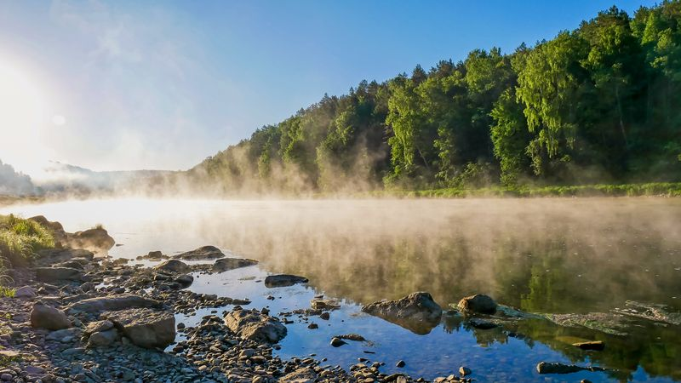

The sun evaporates water from the Earth's surface, including from lakes, rivers and the ocean as well as from the soil.

Plants can absorb moisture from the soil …

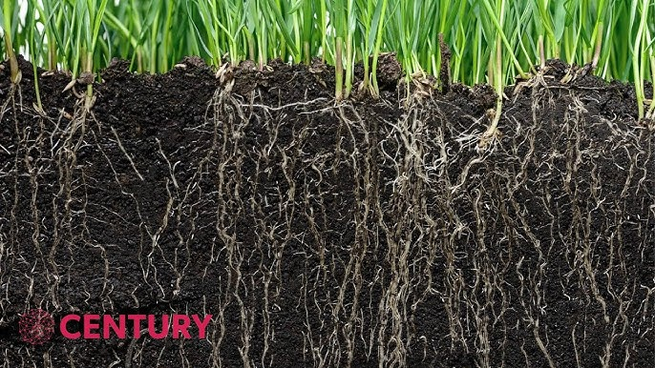

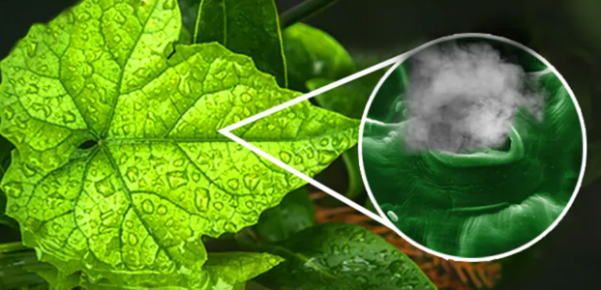

…and release water vapour into the atmosphere as transpiration.

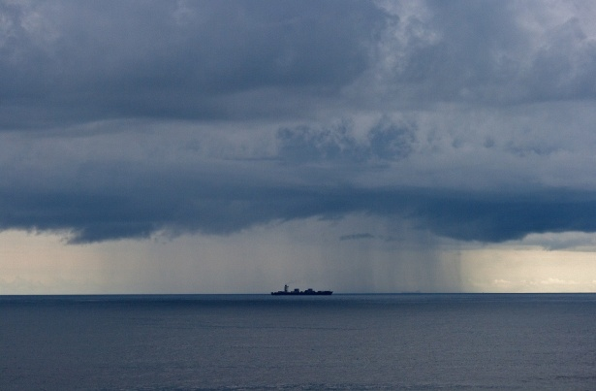

This water vapor rises into the atmosphere where it cools and condenses into water droplets, forming clouds. When the clouds become full they release water as rain or snow – we call this precipitation.

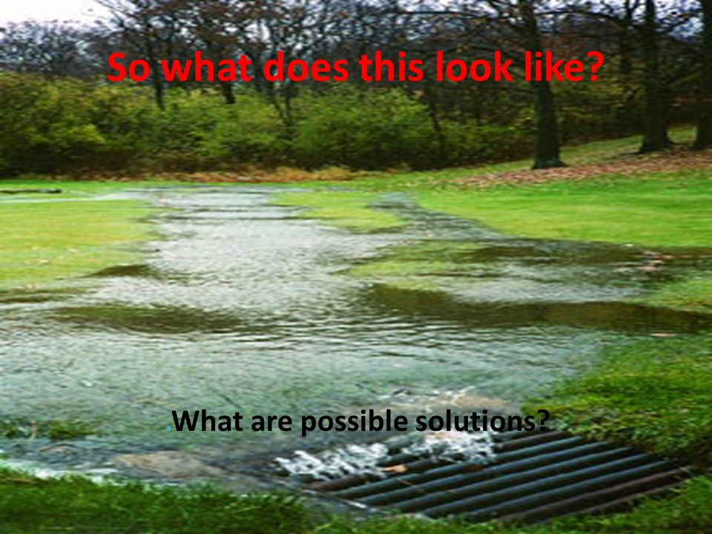

Some of this water flows across the land as run-off and some seeps or percolates into the ground and moves through the soil as ground water.

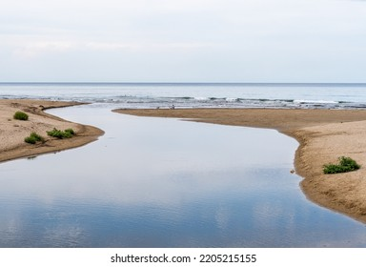

But all of the rain falling on land eventually drains into rivers which flow into the sea.

Human activities can impact the water cycle, affecting the amount of water stored, how it moves, and its cleanliness.