## **Ocean Zones**

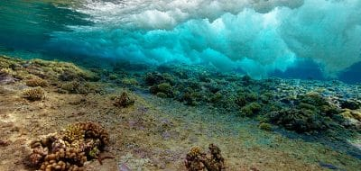

As conditions change with depth, the ocean can be thought of as having 5 layers, with different creatures able to thrive in each.

### Sunlight Zone (Epipelagic)

This region has the most light and heat, and goes from the surface to 200 m. Photosynthesis can only occur in this layer so it is where most phytoplankton live (and zooplankton too, since they need their plant food and oxygen). Most whales live in this zone although some can dive more deeply. The continental shelf and coral reefs are in this zone. Commercial fishing mostly targets this zone as it’s where most oceanic organisms live.

Sunlit zone. [Woods Hole Oceanographic Institute]

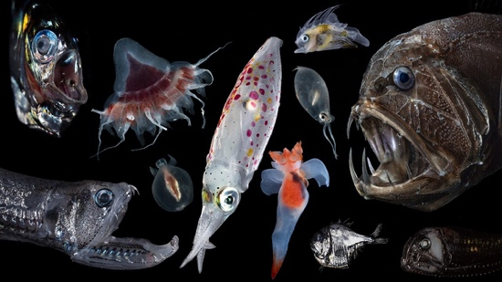

### Twilight Zone (Mesopelagic)

From 200 m to 1,000 m, this zone is inhabited by animals like jellyfish, crabs, and fish, living where there is only dim light. Giant squid are thought to live here, although no-one really knows. This zone has no plants. Many animals migrate upwards during the night to feed under the cover of darkness, actively taking organic carbon deeper into the ocean. In WWII, sonar operators were puzzled by an apparent seafloor at 500m during the day rising at night, due to this migration.

Animals in the twilight zone. [Woods Hole Oceanographic Institute]

### Orpheus - Woods Hole Oceanographic InstitutionMidnight Zone (Bathypelagic)

From 1,000 – 4,000 m, this zone is in perpetual dark -ness and cold, at about 4 oC. Animals living here can have big mouths and sharp teeth in order to eat anything they find. They mostly rely on food and nutrients that fall from the upper zones. This is the largest zone, accounting for 70% of seawater. The Titanic lies at 3,800 m.

**Sea Floor Zone (Abyssopelagic)**

Orpheus submersible, built to withstand hadal depths. [Woods Hole Oceanographic Institute]

At depths up to 6,000 m, it is not only very cold and dark but at extreme pressure too. This area is also called the abyssal plains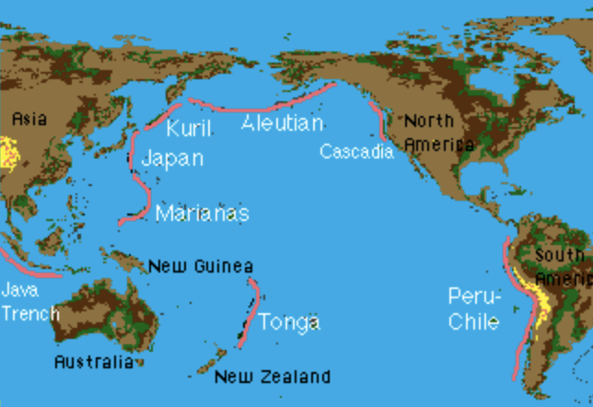. Here many animals are bioluminescent meaning they can make light with their own bodies’ chemical reactions. The inhabitants include sea spiders and vicious-looking viperfish.

### Trench zone (Hadalpelagic)

The deepest layer, at 6,000 – 11,000 m deep, is also called the hadalpelagic zone after Hades, the Greek god of the underworld. Here the pressure is huge, which is why organisms living here have that a hard/flat structure to their bodies. The few animals live on the steep walls of canyons and trenches, e.g. sponges, sea cucumbers, and tubeworms. There they feed solely on dead or decaying material that falls from the ocean layers above.

Oceanic Trenches. [Oregon State University]

Remember that going from the surface to the sea floor there will be some rocky surfaces at each level.

Adapted from <https://www.livinglifeandlearning.com/ocean-zones-worksheets.html>

**Ocean Zones Activity**

1. Prepare sets of cards with different ocean animals – see p3. Make enough sets of cards for groups or partners in your classroom.

2. Give them the diagram of the sea layers – see p4. . It works better printed on A3 than A4. Students could colour the layers: light blue – teal – blue – navy blue – dark navy blue

3. Give each group a set of cards and have them classify the organisms into the zones that they think they are in. The text gives them some help but there will be some they need to think about or research.

Based on an activity from<https://www.brightinthemiddle.com/7-ocean-zones-lesson-ideas/?srsltid=AfmBOorFc5pHVWZB9ga5DwT7X9wjJsrzeRcLlbJqYEaezf71fFuj5N8Y>

Cards

Cut out before giving to students as they are in order

|  |  |  |
| --- | --- | --- |
| Plankton | Blue whale  Blue whale – Australian Antarctic Program | Sea Turtle  Green sea turtle, Pacific green turtle | DinoAnimals.com |
| Giant squid?  Picture | Cuttlefish  Cuttlefish? More like 'cuddlefish' after you read these 5 amazing facts |  Animals Australia | Giant Japanese Spider Crab |
| Deep sea anglerfish  Sea of love: Behind the unusual sexual parasitism of deep-water anglerfish  | YaleNews | Pelican Eel  Picture | Blobfish  Blobfish, facts and information |
| Sea spider  Sea Spiders Pump Blood With Their Guts, Not Their Hearts - The Atlantic | Viperfish  SCIplanet - Monsters of the Ocean: The Grotesque Pacific Viperfish | Shrimp  Picture |
| Sea cucumber  Picture | Tube worm  Giant tubeworm • MBARI | Brittle star  Brittle star | Deep-Sea, Segmented Arms, Radial Symmetry | Britannica |

