University of Waikato – Chemical & Process Engineering
The University of Waikato is proud to announce a significant evolution in its Chemical Engineering degree. Better reflecting the content of the program and employment opportunities for our graduates, the program has undergone a name change to Chemical and Process Engineering (previously Chemical and Biological Engineering). This updated name better aligns with current industry trends and the diverse career pathways available to graduates.
In tandem with the name change, the entry requirements for the program have been revised to ensure accessibility for a wider range of students while maintaining academic rigor. The entry requirements are now a minimum of 16 credits in NCEA at level 3 in calculus and a minimum of 14 credits in NCEA at level 3 chemistry or physics. These adjustments aim to attract motivated individuals from varied educational backgrounds who are passionate about engineering solutions for a sustainable future.
Additionally, the program now offers elective themes that guide students to tailor their studies to specific interests. These themes include chemistry, renewable energy, AI & digitalisation, materials, food & microbiology, health & genetics, and water & the environment. These elective themes provide students with the flexibility to specialise and develop expertise in areas of growing global importance.
We are excited about these developments and the opportunities they bring for aspiring engineers. For more information, please visit https://www.waikato.ac.nz/study/subjects/chemical-and-process-engineering/.

Bring Chem-E-Car to Your Classroom!
The University of Waikato is excited to offer an engaging Chem-E-Car activity for Year 12-13 chemistry classes across regions including Waikato, Auckland, Bay of Plenty, Taranaki, Central North Island, and Northland. Inspired by the international Chem-E-Car competition, this hands-on activity introduces students to chemical engineering principles in a fun and interactive way.
Each session runs for approximately 1–2 hours, with all materials, chemicals, and Chem-E-Car models provided, along with expert facilitators. The activity was piloted in Auckland and Waikato in 2024 in the last week of term, where it received fantastic feedback from students.
We are also currently developing a Chem-E-Car kitset and supporting resources for teachers interested in running this activity themselves in the lower North and South Island high schools.
If you’re keen to bring the Chem-E-Car experience to your classroom in 2025 (either the UoW run activity or by Kitset), we’d love to hear from you!
For more information or to express interest, please contact Dr Martin Atkins (martin.atkins@waikato.ac.nz).

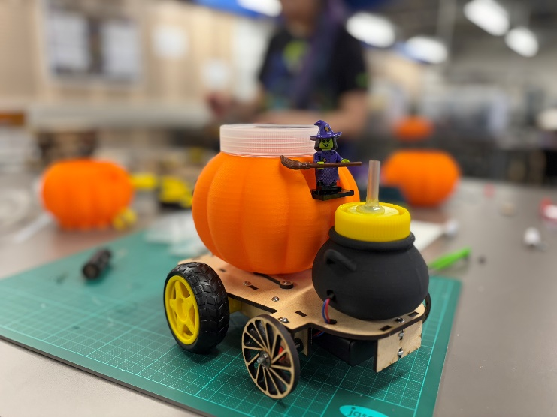
University of Waikato Chem-E-Car

