Forensic Science

 Activities for middle school

[Fingerprinting](http://www.geocities.com/Athens/Atrium/5924/forensicscienceactivites.htm?200923" \l "fingerprinting#fingerprinting) **|** [Shoe Prints](http://www.geocities.com/Athens/Atrium/5924/forensicscienceactivites.htm?200923#shoe prints#shoe prints) **|** [Lip Prints](http://www.geocities.com/Athens/Atrium/5924/forensicscienceactivites.htm?200923#lip prints#lip prints) **|** [Handwriting analysis](http://www.geocities.com/Athens/Atrium/5924/forensicscienceactivites.htm?200923#handwriting analysis#handwriting analysis) **|**

**|** [Chromatography](http://www.geocities.com/Athens/Atrium/5924/forensicscienceactivites.htm?200923#ink pen chromatography#ink pen chromatography)| 4 Readings

**Fingerprinting**

Have students read the handout [Fingerprinting Background Information](http://www.geocities.com/Athens/Atrium/5924/fingerprintingbackground.htm).  Divide the class into groups of 4-5 students.  Give each student a sheet where they can record their group's fingerprints.  The easiest way to  record fingerprints is to have students rub an area on a piece of paper with a pencil.  The students then rub their fingers over the graphite on the paper.  Next, apply a small piece of tape to the finger, lift and place the tape on the sheet of paper.  You will then have a record of each student's fingerprints.  You may also place the tape on a sheet of overhead projector film and then you can project the image of a fingerprint for the entire class to see.  Make a copy of the [fingerprinting record sheet](http://www.geocities.com/Athens/Atrium/5924/fingerprintingworksheet.htm) for each group so that you may use it in this activity and future crimes.  Choose one set of fingerprints to be those of the culprit in each case the students solve involving fingerprints.

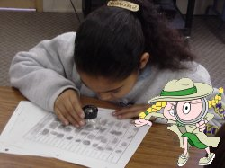     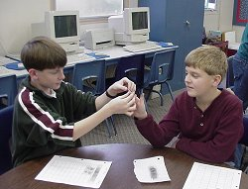

**The case:**

Yesterday, someone put salt in the sugar bowl on the teacher's table in the lunchroom.  Later in the day  a large jar containing a mysterious white substance was found stashed behind the curtain on the stage.  The substance was later determined to be salt.  Upon investigation, a set of fingerprints was found on the jar.  Your job is to examine the fingerprints and decide if anyone in your class is the culprit in this crime..

Additional Fingerprinting Activities:

Dusting for fingerprints:  Rub your finger across your nose or through your hair.  Make a fingerprint on a clean glass.  Sprinkle cocoa powder over the glass and brush the powdered area with a fine paintbrush to remove the excess powder and expose the print.  Place a piece of transparent tape over the print and lift the print from the glass.  If you use a dark glass or piece of plastic, use talcum powder instead of cocoa to lift the print.

Give each student a small piece of metal or plastic.  Have them rub their finger over their nose and make a fingerprint on the object.  Place the object in a jar and place several drops of superglue into the jar.  Be sure not to get the superglue on the print.  Close the lid of the jar and wait approximately 30 minutes.  The print will appear to be white.

**Shoe Prints**

To begin this activity, you need to have each student bring in an old shoe to use for making prints the week before the activity begins.  Paint the bottom of each shoe with black tempera paint and then place the shoe on a large sheet of white paper to make a print of the sole of the shoe.  The next activity is to make a plaster cast of individual students' shoes.  Have each student bring in a shallow box about the size of a shirt box. The lid of a large shoebox will work also.  Fill the box with wet Plaster of Paris.  Have the student press down on the plaster with his old shoe.  This will make an imprint of the sole of the shoe in the plaster.  Keep the shoe in the plaster until the plaster hardens, then remove the shoe. Make one extra set of shoeprints for one or two of the shoes.  These will be the prints of the culprit in the crimes you present to the class to solve.

**Lip Prints**

Read the [Lip Prints Background](http://www.geocities.com/Athens/Atrium/5924/lipprintsbackground.htm) sheet and then complete the activities below.

Before class have 10 people make a lip print on an index card.  Label the back of each card Suspect 1, 2, 3, etc.  Have the person designated as the guilty party make two copies of their lip print.  Label the back of the second lip print "guilty party."  Have the students compare the lip prints of the suspects to the guilty party.

**The Case:**

A student at Dannelly School has been writing graffiti in lipstick on the girl's bathroom mirror.  She has been signing her work with her lip print.  The custodian is having to clean the mirror several times each day to remove the graffiti and is getting tired of this prank.  For the first hour of school he makes a list of the girls seen leaving the girls restroom.  The principal has each of the ten girls seen leaving the restroom make their lip print on an index card to compare to the lip print on the bathroom mirror.  Your task is to compare the lip prints of the suspects to the lip print found in the bathroom and identify the culprit.  Record your findings.

Additional Lip Print Activities:

Before class, have someone make a lip print on a paper towel.  Have several lipsticks which are similar in color to use in the experiment.  Students will make chromatograms of the various types of lipsticks to determine which lipstick was worn by the guilty party.

Cut the lip print on the paper towel into strips.  Give one strip to each group of students.  Next, give each group 5 plain strips of paper towels.  Have each group make a lipstick smear on one end of each blank paper towel with one of the five suspect lipsticks and label them #1-#5.   Place 1/2 inch of fingernail polish remover (acetone) in 6 different glasses for each group.  Loop the paper towel strip over a pencil.  Place the pencil over the top of the glass with the paper towel strip hanging down the center of the class.  Make sure the lipstick end of the paper towel strip is toward the acetone.  Have the end of the paper towel touch the acetone.  Observe how the lipstick separates into different colors on the paper towel.  Compare the chromatograms of the five suspect lipsticks to the chromatogram of the lip print.  Use the [lipstick chromatogram sheet](http://www.geocities.com/Athens/Atrium/5924/lipprintchromatography.htm) to record your findings.

**Handwriting Analysis**

Read the [handwriting background sheet](http://www.geocities.com/Athens/Atrium/5924/handwriting.htm) then complete the activities below.

Before class, have 10 different people (not your students) write the following on a piece of notebook paper in cursive.  Have one person write the note twice.

                    Dear Mrs. (insert the teacher's name),

                         Please excuse Allison from school yesterday.  She was sick with a high fever.

                    Sincerely,

                    Mrs. Smith

Place a number on the back of each letter.  Make sure you keep a record of whose letter gets what number.

**The Case:**

Allison was absent from school on Monday.  When she returned, she gave the teacher an excuse she said her mother wrote.  The teacher was suspicious because the handwriting looked more like a student's than an adult's.  Allison finally admitted that she had played hooky from school on Monday and had had one of her friends write the note for her.  She refused to tell who had written the note.  She said she didn't want to get anyone else in trouble.  Your job is to examine the note and determine who wrote the ransom note.  Record your findings.

**Chromatography**

Read the chromatography background page and then complete the following activity.

In this activity, students must decide which ink pen wrote a ransom note.  Before class, write a fake ransom note with a black ink pen on a piece of filter paper.  You could make the note say anything you want, such as.... "If you want the classroom digital camera returned, put $250.00 in an envelope and leave it under the big plant in the school lobby at 2:30.  Come alone and leave as soon as you leave the money."  Wrap a piece of masking tape around each of 5 black ink pens and number them from 1 to 5.  Make sure you remember which number wrote the ransom note.

**The Case:**

Someone has stolen the classroom digital camera!  We received this ransom note this morning.  I think this ransom note was written by a student in the class using one of the ink pens on the teacher's desk.  We are going to use chromatography and try to determine which pen wrote the ransom note.

Cut 1/2 inch by 5 inch strips of filter paper.  Give each group of students 5 blank filter papers and one filter paper with a line 1/4" from the bottom written with the ransom note pen. Have the students make a line 1/4" from the bottom of each filter paper strip with one of the five suspect ink pens.  Have them write the number of each ink pen at the top of the filter paper strip in pencil.

Place 1/2 inch of fingernail polish remover (acetone) in 6 different glasses for each group.  Loop the filter paper strip over a pencil.  Place the pencil over the top of the glass with the filter paper strip hanging down the center of the class.  Make sure the ink print end of the paper towel strip is toward the acetone.  Have the end of the filter paper touch the acetone.  Observe how the ink separates into different colors on the paper towel.  Compare the chromatograms of the five suspect ink pens to the chromatogram of the ransom ink pen.  Use the [ink pen chromatogram sheet](http://www.geocities.com/Athens/Atrium/5924/inkpenchromatography.htm) to record your findings.

<https://www.nclark.net/ForensicScienceActivities.doc>

as none of the readings are any longer online, new ones were created below

Lip Prints

The lips have a characteristic pattern of skin creases called lip prints. As these are unique to each individual, they can be used as a means of forensic identification. Study of lip prints is called Cheiloscopy.

One of the earliest workers in this field was “Dr. Martinez Santos from Brazil who classified the furrows on the lips and showed that they can be used for identification”. In the past several studies were conducted in various specialties in different parts of the world such as Czechoslovakia, Germany, Italy, France, Great Britain and Iran.([4](https://pmc.ncbi.nlm.nih.gov/articles/PMC5460983/#R4)) In the last decade, lip print studies attracted attention as a new tool for human identification. Cheiloscopy was first described by Fischer in 1902.([4](https://pmc.ncbi.nlm.nih.gov/articles/PMC5460983/#R4)) Locard recommended usefulness of lip prints in criminal investigation and personal identification([5](https://pmc.ncbi.nlm.nih.gov/articles/PMC5460983/#R5)).

A group of scientists led by Archana Alzapur studied lip prints using 100 randomly selected undergraduate medical students. They obtained a lip print from each subject and analysed its pattern.

The lips were cleaned and a thin layer of dark red coloured lip-stick was applied and the subjects were asked to spread it evenly. The hinged portion of folded bond paper was placed between the lips and they were instructed to press their lips by applying pressure evenly. It was then unfolded and the lip image was studied using a magnifying lens.

The Suzuki and Tsuchihashi classification was used to categorize lip prints into one of six types:

* Type I - A clear-cut groove running vertically across the lip
* Type Ia - Partial-length groove of Type I
* Type II - A branched groove
* Type III - An intersected groove
* Type IV - A reticular pattern
* Type V - Other patterns

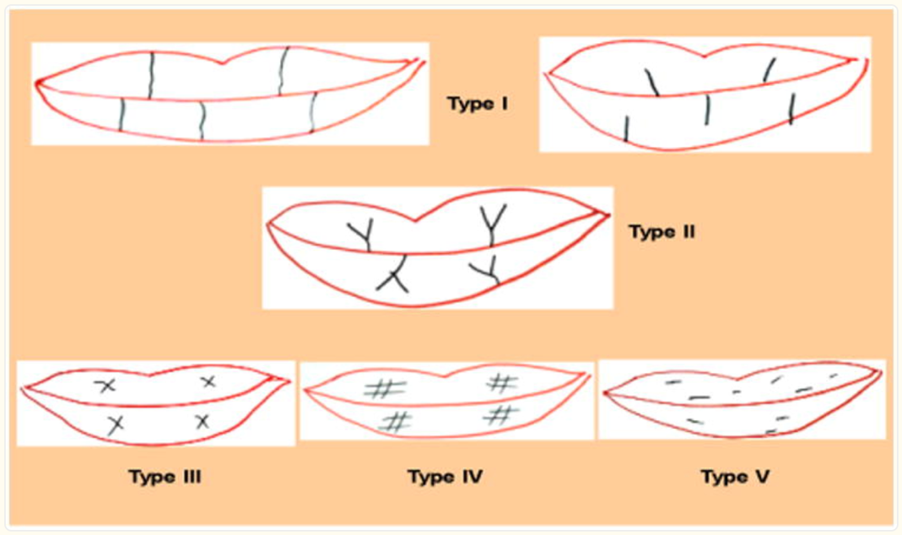

This study found type 1 was most common amongst these students

Alzapur, A., Nagothu, R. S., & Nalluri, H. B. (2017). Lip prints-A study of its uniqueness among students of MediCiti Medical College. *Indian journal of clinical anatomy and physiology*, *4*(1), 68.

Fingerprints

We all have a fine pattern of lines in the skin on our fingertips. These friction ridges are also found on toes and hand palms and feet soles. They are thought to help us better feel fine textures and also give better grip, especially when surfaces are wet.

When our fingers touch a smooth surface we can leave an imprint of that ridge pattern. These fingerprints are left by moisture that is mostly water and salts from our sweat but may also include oils from cosmetics and food residues.

Fingerprints are unique to an individual – even identical twins have slight differences. Most scientists would agree that these patterns are inherited. Human fingerprints are also detailed, difficult to alter, and last for the life of an individual. This all makes them suitable as long-term markers of human identity.

Fingerprints were found on the wall of Egyptian tombs and used in ancient China to “sign” documents. There were even records showing fingerprints were taken from criminals in China and Babylonia. The first western record of fingerprints being used to solve a case was in Argentina in 1892 when a bloody fingerprint left at the scene showed a woman had murdered her 2 sons. A formal system of using fingerprints in crime investigations began in both UK and USA in the early 1900s.

Fingerprints have become an important tool in forensic science i.e. to identify who perpetrated a crime. But it is also useful to identify the injured (when they can’t speak) or dead, e.g. after a natural disaster.

Fingerprints are routinely collected from the pad on the last joint of fingers and thumbs of suspects, physically using black ink onto a white card or digitally onto a glass plate.

Fingerprints are classified into three main types as below with common prevalence

Loop (60-65%) Whorl (30-35%) Arch (5%)

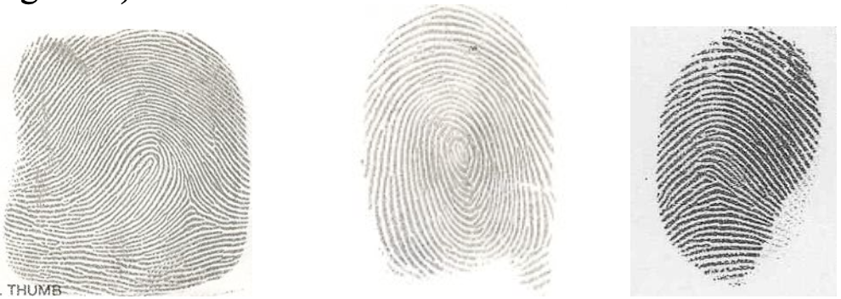

The ridges enter and leave from The ridges form in a circle The ridges enter from 1 side

the same side around a central point and leave from the other

Fingerprints can most easily be collected from smooth surfaces such as metal, glass, plastic or painted wood. Where they are not clearly visible fingerprints can be shown using chemicals like ninhydrin. Fingerprints will show on nonporous surfaces using a fine powder and brush, then transparent tape can be used to lift the fingerprint off the surface. Fingerprints may be absorbed into porous surfaces, but iodine fumes have been found to show up fingerprints on paper.

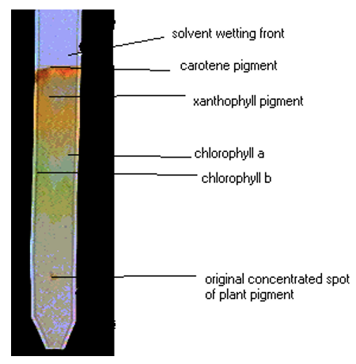Chromatography

You may remember that mixtures are made up of different substances that are not chemically joined. E.g. air is made of a mixture of gases (mostly nitrogen and oxygen) while soft drink is a mixture of water, sugar and carbonic acid.

Chromatography is a way of separating a mixture of different pigments. It was first developed by a Russian botanist in 1905 to separate the different pigments in plant leaves.

A chromatograph of spinach showing the four pigments in its leaf. [Kaiser Science]

Plant leaves are green, and we learn this is due to the pigment chlorophyll. However, the situation is more complex than that. There are two types of chlorophyll and it is not the only pigment in leaves. There is also an orange pigment, carotene, and a yellow pigment, xanthophyll, which become more obvious in autumn.

We can use chromatography to show each of these pigments in a living leaf. To start, we chop up some leaves and put many drops of the resulting liquid in one spot on a strip of filter paper. This is then sat in a solvent that is absorbed and travels up the paper, carrying the pigments with it. The pigments stop moving at different distances, according to how heavy the particles are. Different leaves will have different pigments. This method, sometimes called paper chromatography, can also be used to separate the different pigments in ink and dyes.

Another method is gas chromatography, which can separate substances like petrol. In the image below, each peak represents a different substance in petrol.

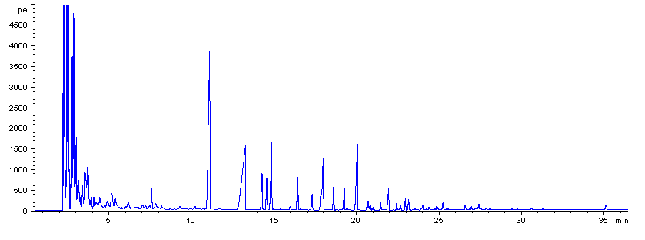

Handwriting Analysis

In forensic science, handwriting experts are usually called in for 2 main reasons

* When a signature is thought to be forged
* When there are two or more samples of handwriting that must be compared to check if they were written by the same person.

In both cases a questionable document is compared to a known document e.g. a signature or a sample piece of writing by the suspect.

Documents vary greatly and it is the job of the document examiner to find out as much about the documents as possible. This can include examining the paper itself, inks, writing style and looking for alterations, indentations and identifying any other clues that the document may provide to help with the investigation.

Handwriting analysis cannot provide insight into the writer’s personality, gender, age, ethnicity or level of education, despite what some may claim.

Handwriting is quite distinctive. No two people write alike. By the late teenage years a person’s writing has matured to a point where the handwriting style is quite unique. Although writing can change based on the person physical or emotional state, the position they are writing in and the tools they are using to write with, there are still similarities to their basic style.

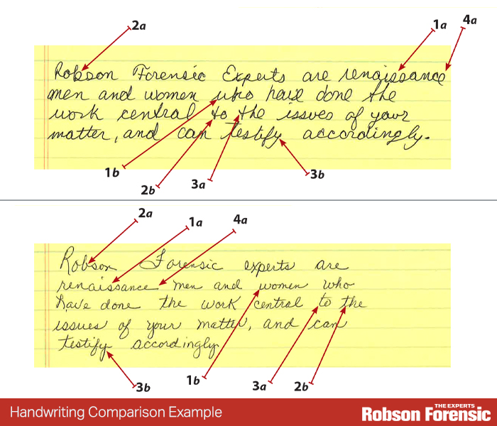

Some characteristics of handwriting that can be analysed:

* Slant – backwards, forwards or straight up and down?
* Connections between letters – full, partial or no connections?
* Ratio of relative height, width & size of letters.
* Spaces between words – narrow, wide or no spaces?
* Spacing between lines – touching the lines above and below, only touching one line, a long way apart,
* Pressure of the writing implement – fine, firm, heavy?
* Position of the dots on i’s and crosses on t’s.
* Beginning and ending strokes – straight, curled, long, short, an upstroke or a down stroke
* Unusual letter formation – lower or upper case

An expert analysing handwriting can generally tell if a person is right or left handed. Right-handed writers pull the pen across the page, so the pen follows the wrist. Left-handed writers push the pen across the page and write ahead of the wrist. These two completely different actions put different emphasis on the down and up strokes in letter formation. Even is the actual shape of each letter is very similar you can identify fine differences based on the hand used.

Criminals may try to

* Reproduce the signature of another person – they need to write at the same speed as the original, with the correct letter formations, height ratio and pen pressure. This is difficult to do.
* Trace a signature – often detectable due to poor line quality (not smooth, fluent lines) and a lack of shading difference (the pen ink will be distributed evenly).
* Disguise their own writing – they need to change the slant or size or add extra strokes. The more words a person writes the more difficult it is to suppress their normal writing style.