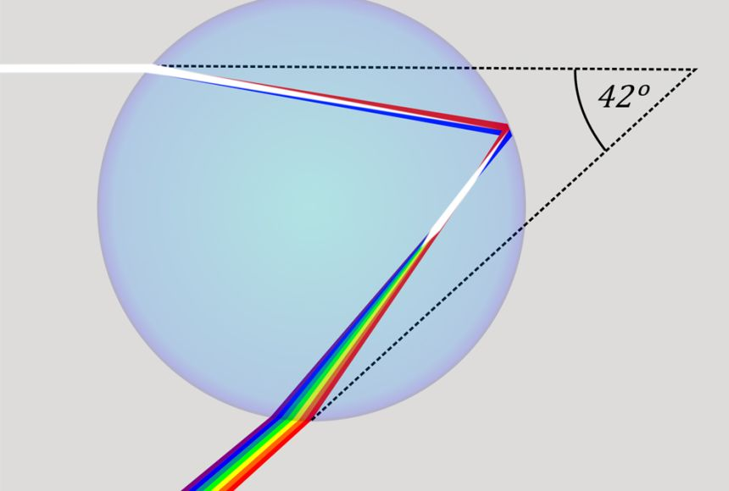**Rainbow**

A rainbow is a multi-coloured arc made by light striking water droplets.

The most familiar type of rainbow is produced when sunlight strikes raindrops in front of a viewer, and returns at a precise angle (42o). Rainbows can also be seen in fog, sea spray, or waterfalls.

A rainbow is an optical illusion—it does not actually exist in a specific spot in the sky. The appearance of a rainbow depends on where you're standing and where the sun (or other source of light) is shining. The light source is usually behind the viewer.

Fig.1 Rainbow optics. Light is refracted as it enters a water droplet, reflected off the back of the droplet & refracted again as it exits. [KES47]

Rainbows are the result of the refraction and reflection of light. Both refraction and reflection involve a change in a wave's direction. A refracted wave may appear bent, while a reflected wave might seem to bounce back from a surface or other wavefront. See fig. 1

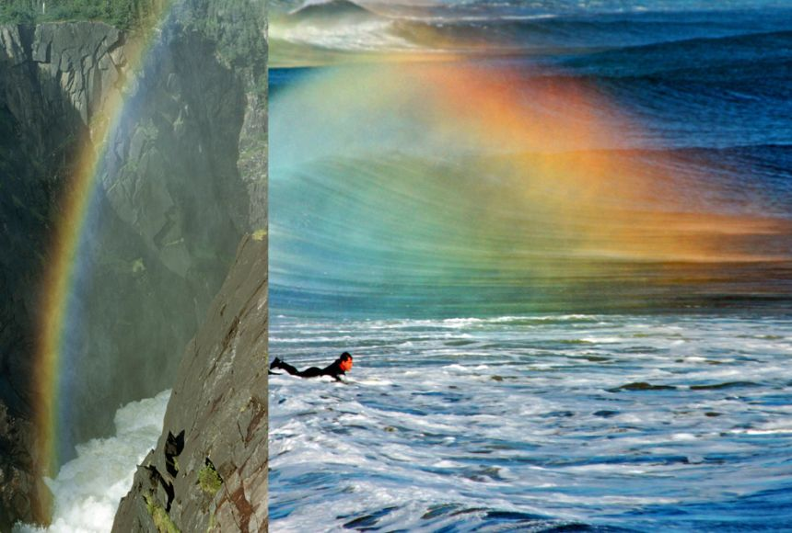Light entering a water droplet is refracted. It is then reflected by the back of the droplet. As this reflected light leaves the droplet, it is refracted again, at multiple angles.

The radius of a rainbow is different depending on the medium – rainbows formed by sea spray will be smaller than rainbows formed by rain. This is because saltwater will refract or bend light more than freshwater.

Rainbows are actually full circles – viewers in aircraft can sometimes see these circular rainbows.

Viewers on the ground can only see the light reflected by raindrops above the horizon. Because each person's horizon is a little different, no one actually sees a full rainbow from the ground.

Fig. 2 Rainbows can form anywhere moisture is suspended in the air, including splashing rivers and sea spray. [William Ralph Gray]

**Colours**

A rainbow shows up as a spectrum of light: a band of familiar colours that include red, orange, yellow, green, blue, and violet. The name "Roy G. Biv" is an easy way to remember the colours of the rainbow, and the order in which they appear: red, orange, yellow, green, blue, indigo, and violet.

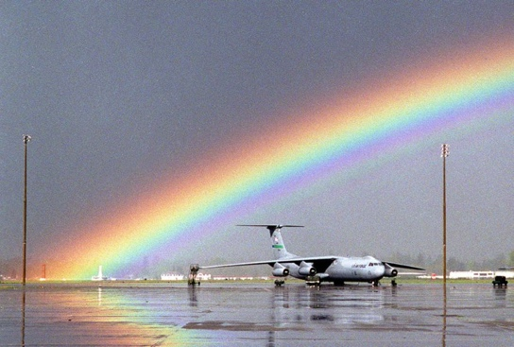White light is how our eyes perceive all the colours of the rainbow mixed together. Sunlight appears white. When sunlight hits a rain droplet and the light is reflected, each colour is reflected at a different angle, separating the spectrum and producing a rainbow. Red usually appears on the outer part of a rainbow's arch, with violet usually s on the inner arch.

**Rainbow Variations**

Double Rainbow – when a faint, secondary rainbow appears above the primary one, it is caused by light being reflected twice inside the raindrop, which reverses the colours – red is on the inner section of the arch, while violet is on the outside.

Twinned Rainbow – when light hits a raincloud with different sizes and shapes of water droplets then 2 bright and distinct rainbows are produced.

Fig. 3 A reflected rainbow on a wet airport tarmac. [Bill Chan, Dept of Defence]

Reflected Rainbow *–* when light rays that have passed through water droplets are reflected onto the surface of water and the 2 endpoints appear to meet.

Red Rainbow – usually appears at sunrise or sunset, when sunlight travels further in the atmosphere. Blue and violet light has been scattered and only red colours are visible in this rainbow.

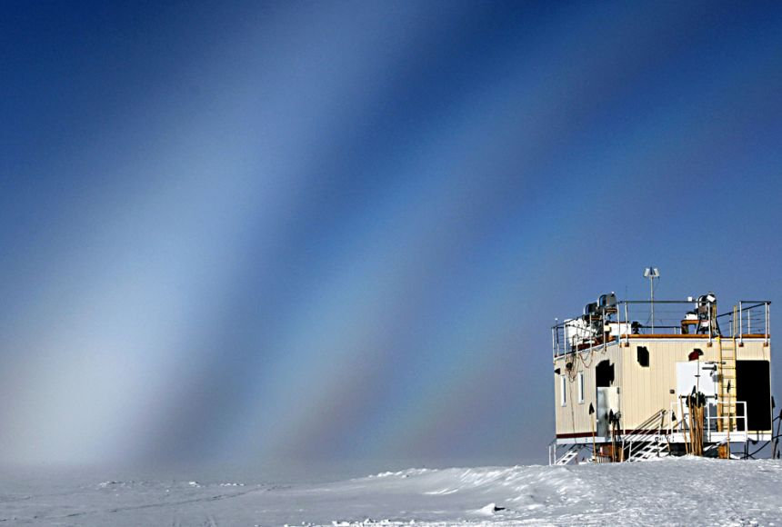Fogbow – when light is refracted and reflected by fog (water droplets suspended in air). Because the water droplets in fog are much smaller than raindrops, fogbows have much fainter colours than rainbows. In fact, some fogbows have few detectable colours at all and appear mostly white, with a reddish tinge on their outer edge and a bluish tinge on their inner edge.

Moonbow – when a rainbow is produced by light reflected by the moon. As moonlight is reflected sunlight, it is much fainter than sunlight, and so moonbows are dimmer than rainbows.

Fig. 4 Fogbow over the National Science Foundation facility, Greenland. [Dr Brant Miller, University of Idaho]

**Māori and rainbows**

New Zealand’s rapid weather changes, frequent rain, distinctive cloud patterns and strong winds all had a huge influence on the daily life of Māori. Each region developed a rich store of words, sayings and traditions relating to the domain of Tāwhirimātea – god of the weather.

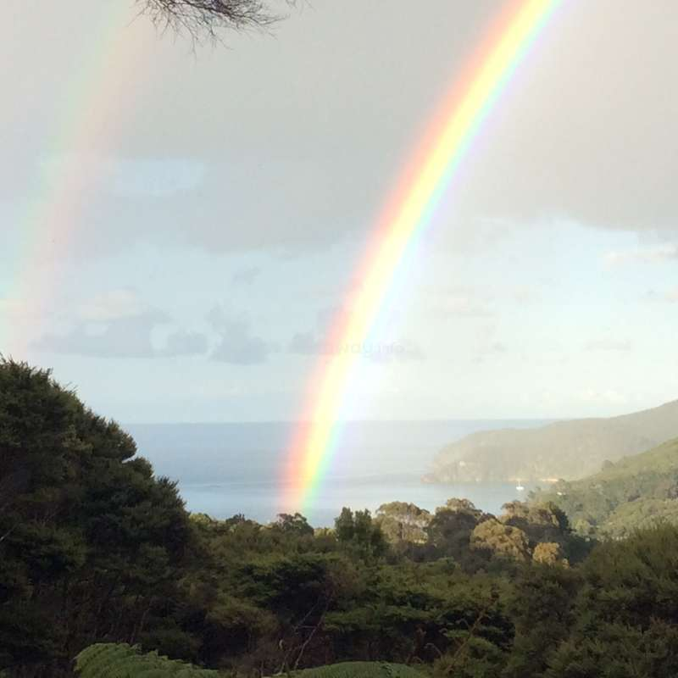In Māori tradition, Tāwhirimātea is the god of the weather. His parents were Ranginui / sky father and Papatūānuku / earth mother, who lay close together. To let light into the world, the brothers of Tāwhirimātea separated their parents. But Tāwhirimātea did not agree to this and showed his anger by sending out his children, the four winds, and clouds that brought rain and thunder storms. The battle between people and the weather continues today.

Māori have a number of names for the rainbow, the most common being āniwaniwa and āheahea. Sometimes rainbows are described as [atua](https://teara.govt.nz/en/glossary#atua) piko, a curved deity. Rainbows can also be personified, in the characters of Kahukura, Uenuku and Haere and others. In tradition, Kahukura appears in the heavens in the form of a double bow. The red lower bow is a female known as Pu-te-aniwaniwa, while the upper, which is darker-hued, is a male known as Kahukurapango.

Fig. 5 A rainbow over Tryphena Harbour [Workaway]

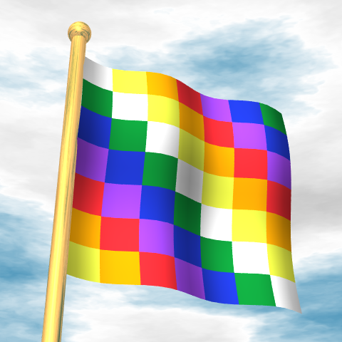**Rainbow Flags**

Rainbow flags usually appear as stripes (bands) of at least five different colours. Rainbow flags have long represented groups championing diversity, respect, and inclusiveness.

The Wiphala flag is a symbol of communities indigenous to the Andes, stretching from modern-day Ecuador to Chile. A Wiphala has been an official flag of Bolivia since 2009, when the nation elected its first indigenous president, Evo Morales. Different arrangements of patchwork squares represent different Andean communities.

The most familiar rainbow flag may be the banner representing the movement supporting civil rights for members of the lesbian, gay, bisexual, and transgender (LGBT) community. The different colours of the LGBT pride flag represent the diverse community itself, which is also known as the rainbow community.

Fig. 6 The Wiphala flag [Wikimedia]

**References**

National Geographic <https://education.nationalgeographic.org/resource/rainbow/>

Te Ara, the Encyclopedia of NZ <https://teara.govt.nz/en/tawhirimatea-the-weather/page-6>