**De-Extinction ?**

There has been much fanfare associated with claims of bringing back extinct species. What is the science behind these claims?

Grey wolf and dire wolf size compared [Roman Uchytel, prehistoric fauna.com]

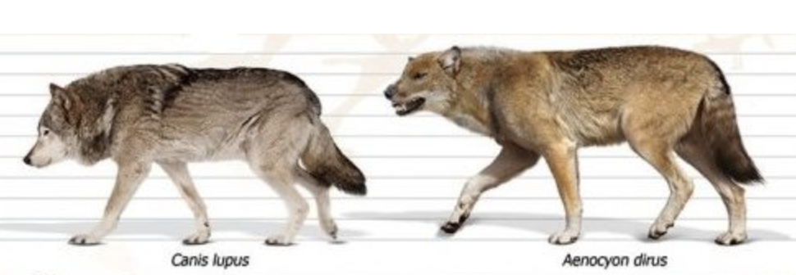

**Wolves**

In April 2025 U.S.-based biotechnology company Colossal Biosciences claimed they had brought the extinct ice age dire wolf back from the dead.

Best known from the TV series Game of Thrones, this animal really did exist in North and South America over 10,000 years ago. The dire wolf, Aenocyon dirus, was similar in size to today’s largest grey wolves, Canis lupus, species found in snowy northern climes. Their skeletons were hard to tell apart, although dire wolves had much larger carnassials (molars specialised for cutting through muscle). Genetic analysis suggests the dire wolf lineage split from a common ancestor about 5.7 mya and evolved in isolation from other canids in the Americas.

Despite the headlines, Colossal has not made true dire wolves. They have genetically modified some grey wolf genes to give them some dire wolf traits.

They did this by: -

1. sequencing DNA from dire wolf fossils and analysing it to identify genes unique to dire wolves
2. using CRISPR technology to edit the DNA of grey wolves to incorporate those unique genes
3. inserting the cells with this DNA into de-nucleated eggs cells from domestic dogs (i.e. cloning)
4. implanting these engineered embryos into the wombs of surrogate dogs.

The three puppies produced were grey wolves with some dire wolf traits (but no dire wolf DNA).

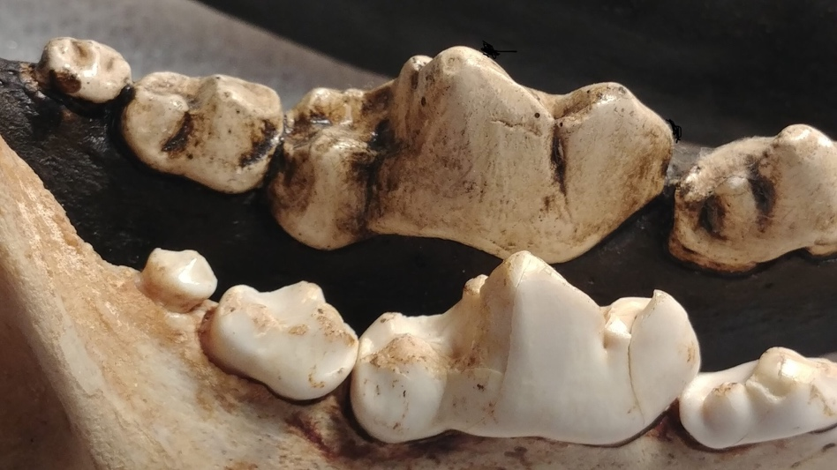 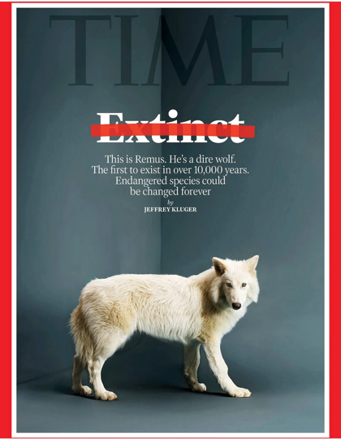

Grey wolf (front) and dire wolf molars. [Ohio History Connection]. 12 May 2025 Time cover [Robert Clark, Time]

**Moa**

Moa roamed Aotearoa for 4,000 years, becoming extinct around 600 years ago. They belonged to a group of birds called ratites, most flightless and some very large. Moa were unique in this group in having no remnant wings. They lived in open forest shrubland dominated by kowhai and lancewood.

In July Colossal Biosciences announced plans to de-extinct the moa in the next 8 years. This is a venture with Ngāi Tahu Research Centre and Canterbury Museum, backed by Peter Jackson’s $15 million. They plan to use a similar process to the dire wolf, analysing DNA from fossil remains and genetically engineering & cloning the genome of a related species to produce similar traits.

However:

* As with dire wolves, moa DNA is degraded and so developing a sequence is a long drawn out process and the quality is not good enough for gene editing or cloning.
* The ratites split from a common ancestor 60 mya so the genes evolved to be very different, making the analysis and gene editing more complex. As well as that, genes for wing formation would need to be found and “turned off”.
* The embryo would need a surrogate egg to grow in. As there are no eggs from living relatives big enough for many moa species, artificial eggs could be needed.
* 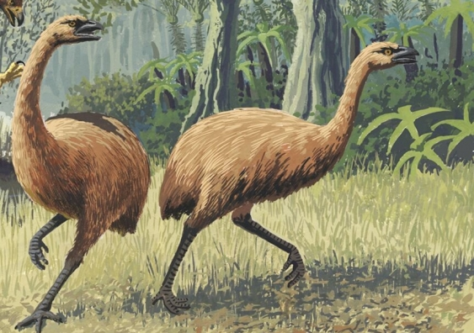Māori whakapapa to moa. And many iwi are deeply opposed to gene editing and de-extinction which interferes with that relationship. It is clear some rūnanga of Ngai Tahu are involved in this project, but, given that moa ranged across the tribal areas of several iwi in the South Island, Māori who work in the field say other groups should be consulted too.
* There is little moa habitat left or much that is similar. The hybrid might struggle to adapt to the new environment or might compete with modern browsing herbivores.
* At least 500 moa would be needed to avoid inbreeding and genetic drift (random loss or retention of genes).

Two moa [John Megahan, PLOS Biology]

**Issues to consider**

As we have seen, creating these hybrids raises important questions. In addition, this process is very expensive, using money and technology that might be better spent conserving existing species at risk, who we struggle to protect.

We do not currently have the technology to bring back extinct animals, despite the hype.

References

Perri, A. R., et al (2021). Dire wolves were the last of an ancient New World canid lineage. Nature, 591(2021), 87–91. <https://ora.ox.ac.uk/objects/uuid:c087f6d0-e084-4558-be53-d503697ce140>

RNZ news <https://www.rnz.co.nz/news/on-the-inside/566642/first-the-dire-wolf-now-nz-s-giant-moa-why-real-de-extinction-is-unlikely-to-fly>?

Science Media Centre <https://www.sciencemediacentre.co.nz/2025/07/09/moa-de-extinction-plans-announced-expert-reaction>

Time cover page, The Wild Collective <https://www.instagram.com/p/DINAJmKS-Dc/>