How the Ear works

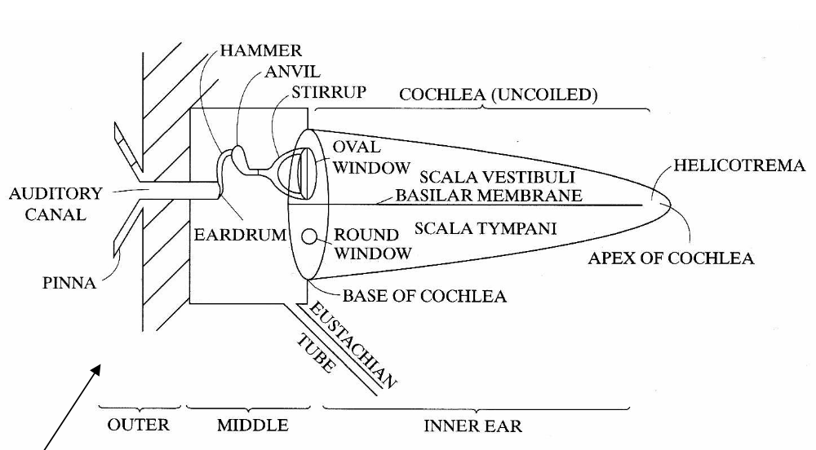

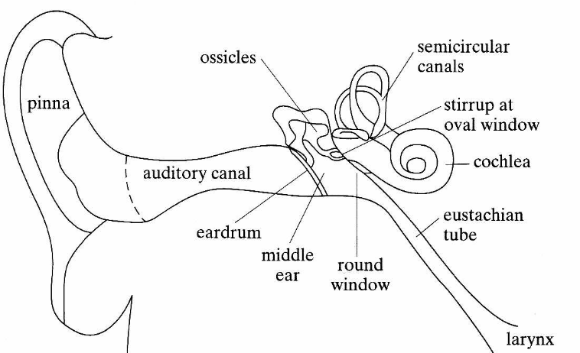

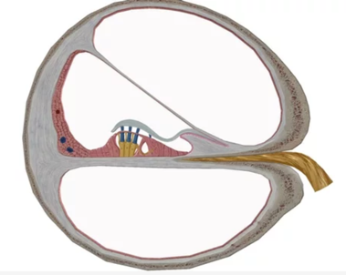

Sound enters the auditory canal and reaches the eardrum, which vibrates, in turn vibrating 3 little bones, the hammer, anvil, and stirrup which transfer the vibration to the oval window. This sets up waves in the liquid inside the cochlea, travelling up one side and down the other to the round window where the movement is damped. The waves in the cochlea excite attached nerve endings, sending signals to the brain.

A cross section of the cochlea

Diagrams from <https://www.lehman.edu/faculty/dgaranin/Physics_of_Sound/PHY140-Spring-2007-07-Hearing.pdf>