**Kia ora koutou**

I have received the following email from NZASE, forwarded from a Principal in relation to a gas tap incident at their school.

Information is as follows for your awareness and to consider on your next review of your gas taps as part of lab checks.

If you have any concerns, I would recommend talking to your Lab Manager, Property Manager, Principal and/or Plumber as applicable for further advice.

**Ngā mihi nui**

**Megan Hay**

Kia ora,

I am just sending this to you in case you feel it needs to be passed onto schools so they can check their gas taps to ensure they do not have the same potential issue that we have.  I will leave that decision to you, however, felt our experience may avoid an issue for others.

The gas taps in our science labs have a yellow tap that opens by turning several turns (much like a standard water tap). These are less than 3 years old.

Yesterday, we had one in use that completely unscrewed with the tap mechanism coming off. As a consequence gas flowed out the top of the tap assembly and caught a nearby flame.  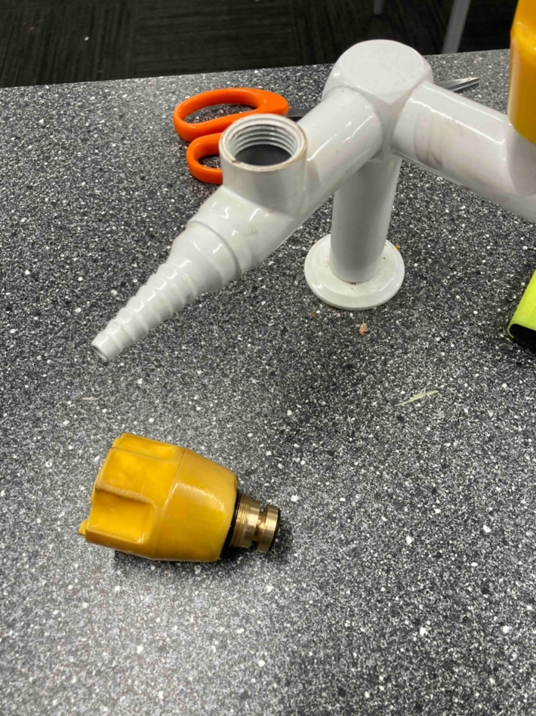The resulted in a good sized fire ball.

We were very grateful for a working emergency stop and that safety processes were followed well.  No one was hurt but this could easily have been very different.

In checking I found a further gas tap that was also not far off coming apart in the same way.

When I turned it fully on it allowed me to continue to turn it unscrewing the entire tap mechanism as shown in the photo.

**So why the email.**  **If you have these types of taps please check them, make sure they can not unscrew in this way.**

The design to me is  flawedand we will be replacing ours with a different option.

Maybe we have a bad batch (the supplier claims that the plastic top should break before it is possible for them to unscrew, however, with at least 2 here this is not the case. We have some real concerns - we only have 1 small

Photo of one as it came apart.

lab with 6 double outlets).

With 30+ years teaching in school labs I have not seen this occur before.