The GSB poster

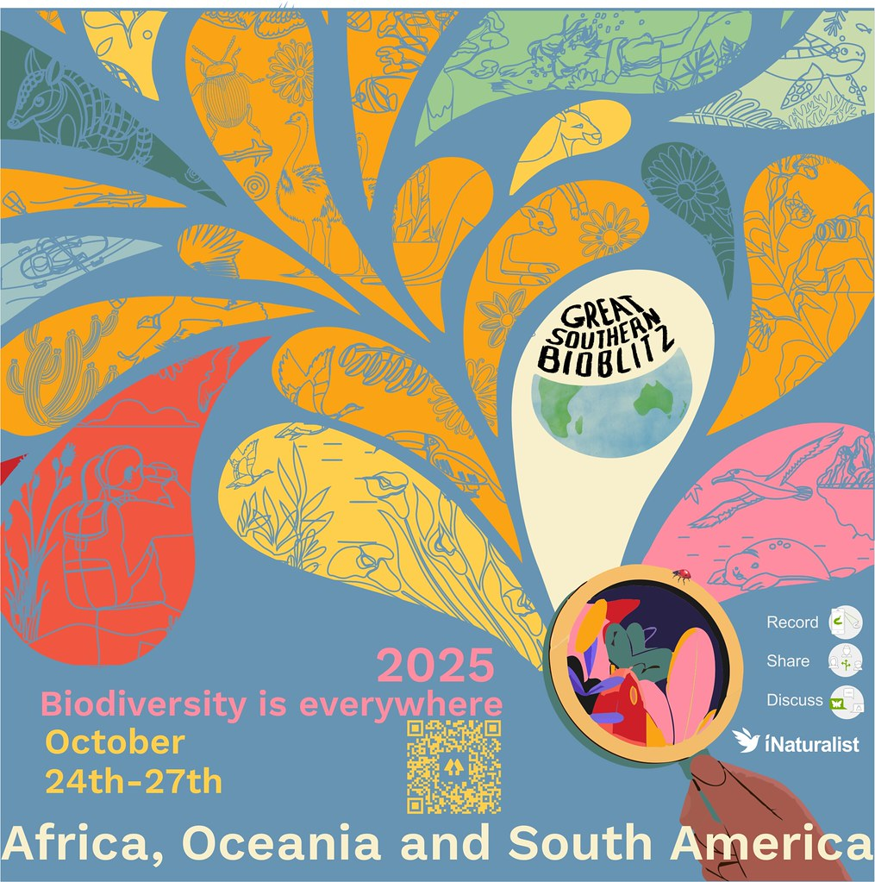

The Great Southern BioBlitz 2025 is not far away! From October 24th–27th, nature lovers across the Southern Hemisphere will unite to document local biodiversity in a massive, collaborative citizen science effort.

Whether you're in the city, bush, coast, or outback—your observations matter. Get ready to explore, observe, and contribute to science and conservation through iNaturalist.

📅 Mark your calendar: Oct 24–27, 2025  
🔍 Counting down!  
🌏 Join the movement. Celebrate biodiversity. Make your mark.

Please join the project, and connect with the organisers on social media

[GSBioblitz - on Facebook](https://www.facebook.com/GSBioblitz)   
[GSBioblitz - on Instagram](https://www.instagram.com/gsbioblitz/)  
[GSBioblitz - on Bluesky](https://bsky.app/profile/gsbioblitz.bsky.social)

<https://linktr.ee/gsbioblitz>.

Share interesting iNaturalist observations, activities, and events.

To keep in touch and receive updates you can register as a participant <https://bit.ly/GSBParticipants> or subscribe on our website if you have not already