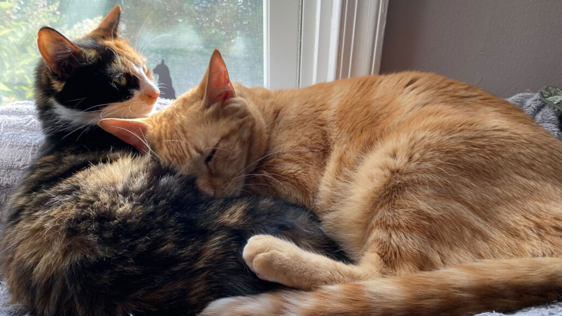**Orange cats get their ginger colour from a single gene ‘cut-out’**

Science News Explores 17 July 2025

Multi-coloured cats, such as calicos and tortoiseshells, also carry this DNA deletion

Cats come in many colours and patterns. And bright orange is one of the most striking. The mystery of what gene gives ginger cats their hue has stumped scientists for decades. Now, two different teams have just turned up the same solution.

A DNA deletion on the X chromosome of domestic cats leads to ginger-coloured fur, two new studies show. Cats with multi-colour coats, like calicos and tortoiseshells, also have the mutation. Both Oscar (orange cat, right) and Alani (calico cat, left) likely have the mutation. [S. Zielinski]

Most kitties with orange fur share the same cut-out in their [DNA](https://www.snexplores.org/article/scientists-say-dna), the new research shows. Even multi-coloured cats with a few ginger patches — such as calicos and tortoiseshells — have this [mutation](https://www.snexplores.org/article/scientists-say-mutation). The DNA deletion makes cells in cats’ hair-growing structures produce a yellow-red pigment instead of the default brown-black hue.

Both teams published their studies in the June 23 issue of *Current Biology*.

**“X” marks the spot**

Researchers knew the bit of DNA, or [gene](https://www.snexplores.org/article/explainer-what-are-genes), linked to ginger fur lay in a DNA bundle called the X [chromosome](https://www.snexplores.org/article/scientists-say-chromosome). Here’s how.

In cats and most other mammals, males usually have one X and one Y chromosome. Females typically have two X chromosomes. As a result, the single X chromosome is very active in all cells of a male cat. But only one of the two X chromosomes is active in each cell of a female cat.

If the ginger fur gene were on the X chromosome, then male cats with that trait would be completely orange. But in a female cat, both X chromosomes would need to carry the orange trait for her to be fully ginger. If only one X chromosome contained the trait, then her coat would likely become a patchwork of orange and black.

Indeed, that is the colour pattern seen among cats. Most completely orange cats are male. Most multi-coloured cats, meanwhile, are female.

Most other mammal [species](https://www.snexplores.org/article/scientists-say-species) don’t get ginger hair based on their sex. Not even famously orange big cats (such as tigers) do. So [domestic cats](https://www.snexplores.org/article/dna-tells-tale-how-cats-conquered-world) possess an unusual mutation, says Chris Kaelin. He studies genetics at Stanford University in California.

**DNA examination**

Kaelin was part of a team that examined the genes of about 30 cats. They hoped to find DNA features shared only by those with orange fur. Their work revealed a [deleted stretch of about 5,000 DNA base pairs](https://www.cell.com/current-biology/abstract/S0960-9822(25)00552-4?_returnURL=https%3A%2F%2Flinkinghub.elsevier.com%2Fretrieve%2Fpii%2FS0960982225005524%3Fshowall%3Dtrue) near a gene called *Arhgap36.* (The cat genome has about 2.7 billion base pairs total.) The removed bit was not in the gene itself, but close enough to affect its activity.

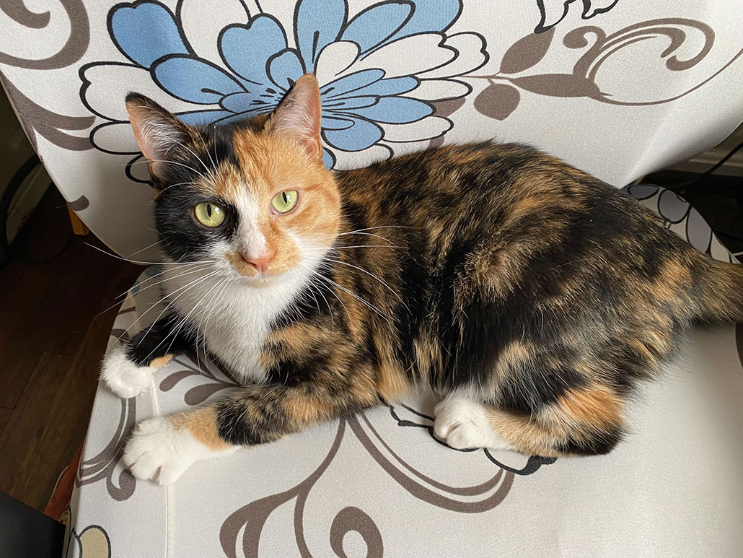The *Arhgap36* gene carries instructions for making a certain protein. The nearby deletion boosted how much of that protein it makes — but only in cells that make [pigment](https://www.snexplores.org/article/scientists-say-pigment). (Pigments are chemicals that impart colour.)

In pigment-making cells, the protein stops genes needed to make the brown-black pigment from turning on. Instead, a yellow-red pigment is produced. It involves fewer genes, so it’s easier to make, explains Greg Barsh. He’s also a geneticist at Stanford University. (Mammals produce only two pigments. Different shades come from other genetic factors.)

A team in Japan [identified the same deletion](https://doi.org/10.1016/j.cub.2025.03.075). This team examined DNA from almost 60 cats. When lots of Arhgap36 protein is made, the genes that make the brown-black pigment become less active, explains Hiroyuki Sasaki. He’s a geneticist at Kyushu University.

Alani — a female calico cat — likely has the DNA deletion on just one of her X chromosomes. That’s why her coat only has some orange. [S. Zielinski]

His team also found that all orange cats from a global database of 258 kitties had the same deletion. Non-orange ones lacked it. Sasaki suspects the trait was passed down from one ancestral cat. That cat lived more than 900 years ago, suggest Kaelin, Barsh and their team-mates. They base this estimate on historical paintings of calicos.

Before these studies, researchers didn’t know *Arhgap36* was involved with a cat’s colouring. It’s mostly active in certain hormone-producing organs, such as the pituitary gland. The gene’s role in ginger hues is unique to domesticated felines.

**Citations**

**Journal:​** C.B. Kaelin et al. [Molecular and genetic characterization of sex-linked orange coat colour in the domestic cat](https://doi.org/10.1016/j.cub.2025.04.055). *Current Biology*. Vol. 35, June 23, 2025, p. 2826. doi: 10.1016/j.cub.2025.04.055.

**Journal:​** H. Toh et al. [A deletion at the X-linked ARHGAP36 gene locus is associated with the orange coloration of tortoiseshell and calico cats](https://doi.org/10.1016/j.cub.2025.03.075). *Current Biology*. Vol. 35, June 23, 2025, p. 2816. doi: 10.1016/j.cub.2025.03.075.

<https://www.snexplores.org/article/cats-orange-fur-ginger-color-gene>

**Power Words**

**base pair:** DNA contains 4 bases either adenine (A), cytosine (C), guanine (G) or thymine (T). DNA has aladder-like structure and the runs are formed of 2 bases, T paired with A or G paired with C.

**cell**: The smallest structural and functional unit of an organism. Typically too small to see with the unaided eye, it consists of a watery fluid surrounded by a membrane or wall.

**chromosome**: A single threadlike piece of coiled DNA found in a cell’s nucleus.

**database**: An organized collection of related data.

**deletion**: The process of removing some specific part or detail; or the things that have been removed.

**DNA**: Deoxyribonucleic acid, a long, double-stranded and spiral-shaped molecule inside most living cells that carries genetic instructions.

**domestication**: A process of producing a tame version of an animal from a wild one.

**feline**: Adjective for something having to do with cats (wild or domestic) or their behaviours.

**gene**: A segment of DNA that codes, or holds instructions, for a cell’s production of a protein.

**genetic**: Having to do with chromosomes, DNA and the genes contained within DNA.

**genome**: The complete set of genes or genetic material in a cell or an organism.

**gland**: A cell, a group of cells or an organ that produces and discharges a substance (or secretion) for use elsewhere in the body, or for elimination from the body.

**hue**: A colour or shade of some colour.

**mammal**: An animal that has hair or fur, secretes milk to feed their young, and bears live young. They also are warm-blooded (or endothermic).

**mutation**: Some change that occurs to a gene in an organism’s DNA. Mutations occur naturally or be triggered by outside factors, such as pollution, radiation, medicines or something in the diet.

**organ**: Various parts of an organism that perform one or more particular functions. For instance, the brain is an organ that makes sense of nerve signals and a plant’s roots take in nutrients and moisture.

**pituitary**: A small pea-shaped gland at the base of the brain that secretes hormones.

**protein**: A compound made from one or more long chains of amino acids. They make up muscle and other tissues. Antibodies, haemoglobin and enzymes are all examples of proteins.

**species**: A group of similar organisms capable of producing offspring that can survive and reproduce.

**unique**: Something that is unlike anything else; the only one of its kind.

**X Y chromosomes**: The two sex chromosomes. Females will usually have two X-chromosomes; males will typically have an X- and a Y-chromosome.