**Conceptual questions**

1. What effect does frequency have on the speed of sound in air? Describe a situation from everyday experience that could be used to verify your claim.
2. A scene in a science fiction movie shows a spacecraft exploding in outer space. At the very same instant, the occupants of a second spaceship located a considerable distance away are shown reacting to the sound and light of the explosion. What two physics errors did the producers make in this scene?
3. At some track events (the 100 m and 200 m dash, in particular) the start and finish lines are far enough apart that a person timing the event with a stopwatch will encounter a serious problem if they start timing when they hear the bang of the starter's pistol.
   1. Why shouldn't manually timed track events start at the sound of the starter's pistol?
   2. When should timing begin?

**Numerical questions**

1. What range of wavelengths in air at room temperature are audible to a human with ideal hearing (ƒ = 20 Hz ~ 20 kHz)?
2. How long would it take a sound wave to travel completely around the earth? (The average surface temperature on earth is about 13.5 ℃, which gives a speed of sound of about 340 m/s.)
3. To the nearest second, how many seconds elapse between when a flash of lightning is seen and when the thunder is heard if the lightning is …
   1. 1 kilometer away?
   2. 1 mile away (1.6 kilometers away)?
4. A sound wave of wavelength 0.70 m and speed 353 m/s is produced for 0.50 s.
   1. What is the frequency of the wave?
   2. How many complete wavelengths are emitted in this time interval?
   3. How far is the front of the wave train from its source?
   4. How far is the back of the wave train from its source?
5. A measurement, a calculation, and a set of related questions.
   1. Measure the horizontal distance between your ears. (This is not easy to do. You will probably be off by a couple of centimeters, but that is OK. An approximate value is sufficient.)
   2. Approximately how long does it take a sound wave coming from a source on one side of your head to travel the distance between your ears? (This is known by audiologists as the interaural time difference or ITD.)
   3. What would happen to the value calculated in part b. if the source of sound was moved forward a bit (not closer to your ear, but in the direction you call forward — anterior, as they say in the medical professions)?
   4. What would happen to the value calculated in part b. if the source of sound was directly in front of you instead of off to one side?
   5. Your brain can actually perceive the interaural time difference (as long as you have two working ears). What does your brain use this information for?

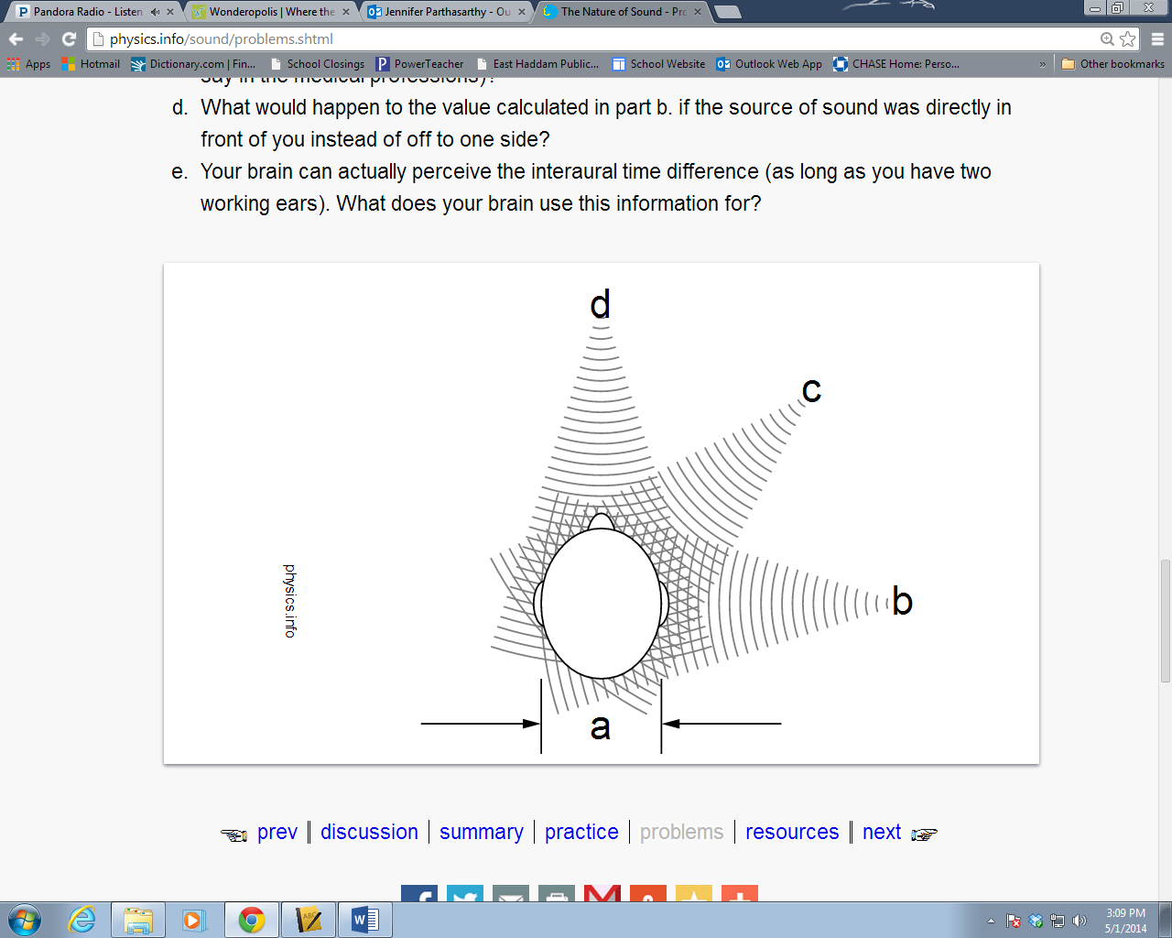 Jennifer Grandin