Vocab games to learn & reinforce te reo Māori

**Marae Jeopardy**

Cut into separate cells, put in an envelope. Students try to match term with meaning

|  |  |
| --- | --- |
| Hui | Meeting, gathering |
| Marae | Complex including forecourt and buildings |
| Tangihanga | Funeral ceremony in which a deceased person is mourned on the marae |
| Karanga | Calling to guests to welcome them onto the marae |
| Manuhiri | Guests, visitors |
| Tangata whenua | Original people belonging to a place, local people, hosts |
| Whaikōrero | The art and practice of speech-making |
| Kaikōrero | Speaker |
| Haka | Chant with dance for the purpose of challenging |
| Waiata | Song following a speech |
| Koha | Gift given by guests to host |
| Whare nui | Meeting house |
| Whare kai | Dining hall |
| Whare paku | Toilet |
| Paepae | Speaker’s bench |

**Concept Dominoes**

Cut out along the heavy lines. Students to place term alongside correct meaning, till all join in a circle

|  |  |  |  |
| --- | --- | --- | --- |
| Land, homeland (also placenta) | Aroha | Compassion, love | Mana |
| Authority, power | Manaakitanga | Kindness to guests | Mauri |
| Life force | Tapu | Sacred, not to be touched | Noa |
| Not tapu | Raupatu | Confiscation, to take by force | Rohe |
| Territory of an iwi or hapū | Taihoa | To wait or delay | Tiaki |
| To care for, look after | Taonga | Treasured possession | Turangawaewae |
| A place to stand or belong to | Whakapapa | Genealogy, kin connections | Whenua |

**Place name Cluster**

Cut out each cell. Students put cards into groups based on the meaning of the words. Give each cluster a title on a blank card

|  |  |  |
| --- | --- | --- |
| Au | Awa | Iti |
| Nui | Kai | Manga |
| Mānia | Maunga | Moana |
| Motu | Ō | One |
| Pae | Papa | Poto |
| Puke | Roa | Roto |
| Tai | Wai | Whanga |
|  |  |  |
|  |  |  |

**Kupu that can be used in the classroom**

Complete the table using these kupu: Ae, Ānana, Aroha mai, Āta marie, E tū, Haere rā, Ka kite anō, Ka miharo, Kao, Kia kaha tonu, Kia ora, Kia tau, Koa, Mā te wā, Pai ana tō mahi, Taihoa, Taki noho, Tēnā koe,

Tikina mai ā koutou pukapuka, Titiro mai, Whakarongo mai, great job, start work, turn this way

|  |  |
| --- | --- |
| **English** | **Māori** |
| Hello | or |
| Good morning |  |
| See you later | or |
| Please |  |
| Thank you (to 1 person) |  |
| Yes |  |
| No |  |
| I’m sorry |  |
| Listen to me |  |
| Be still, settle down |  |
| Get out your books |  |
| Everyone, sit down |  |
| Stand |  |
| Look this way |  |
|  | Huri mai |
| Goodbye (to the person going) |  |
|  | Timata i te mahi |
|  | Te pai hoki o tō mahi |
| Keep it up |  |
| You’re doing well |  |
| I’m proud of you |  |
| That’s it |  |
| Good on you! |  |

**Components of place names**

These are some kupu that are common in placenames:-

Awa, iti, kai, manga, maunga, moana, motu, nui, papa, poto, puke, roa, roto, wai, whanga

Complete the table using these kupu. Fill in the ones you know, then check with your neighbours and then the class. Try to find out about the ones you don’t know.

|  |  |  |
| --- | --- | --- |
| **English meaning** | **Māori name** | **Example of placename** |
| Flat |  |  |
| Food |  |  |
| Harbour |  |  |
| Hill |  |  |
| Island |  |  |
| Large |  |  |
| Lake |  |  |
| Long |  |  |
| Mountain |  |  |
| River |  |  |
| Short |  |  |
| Small |  |  |
| Stream |  |  |
| Sea |  |  |
| Water |  |  |

<https://nzhistory.govt.nz/culture/maori-language-week/100-maori-words>

Mike Stone

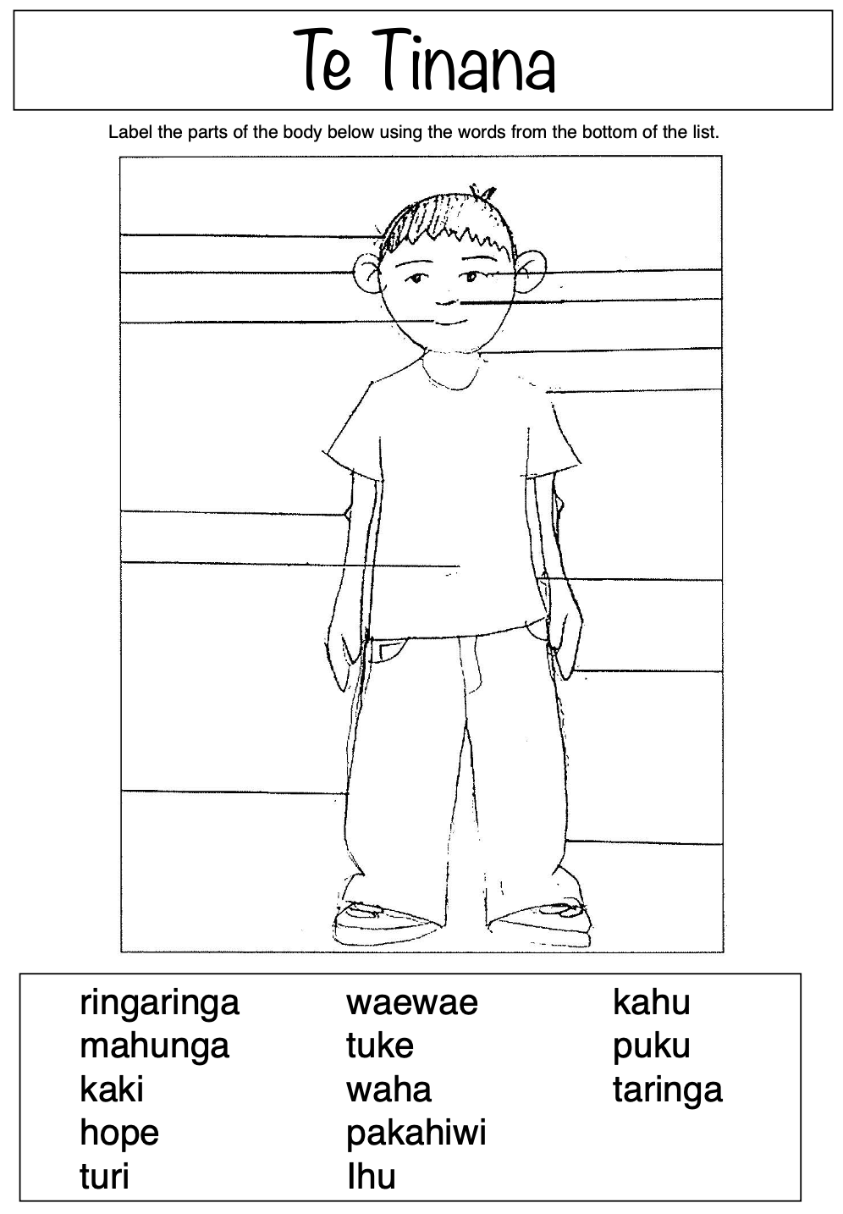

Jo Dawson