Common New Zealand Rocks and Minerals
There are 3 main rock types: igneous, metamorphic and sedimentary. The table below shows a few examples of common rocks.
Igneous | Metamorphic | Sedimentary
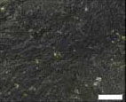  Basalt | 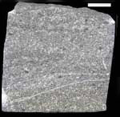  Greywacke | 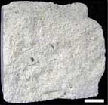  Limestone
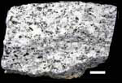  Granite | 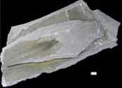  Slate | 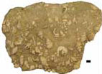  Shell bed
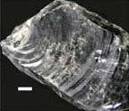  Obsidian | 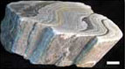  Schist | Greywacke
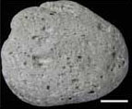  Pumice | 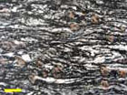  Schist | 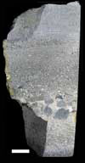  Graded bed
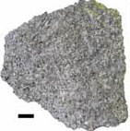  Rhyolite | 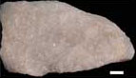  Marble | 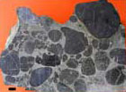  Conglomerate
Igneous | Metamorphic | Sedimentary
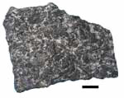  Gabbro |  | 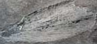  Leaf fossil
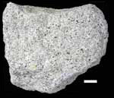
Andesite

Identification of Igneous Rocks
Grain Size | Usual Colour | Other | Composition | Rock Type
fine | dark | glassy appearance | lava glass | Obsidian
fine | light | many small bubbles | lava froth from sticky lava | Pumice
fine | dark | many large bubbles | lava froth from fluid lava | Scoria
fine or mixed | light | contains quartz | high-silica lava | Felsite
fine or mixed | medium | between felsite and basalt | medium-silica lava | Andesite
fine or mixed | dark | has no quartz | low-silica lava | Basalt
mixed | any colour | large grains in fine-grained matrix | large grains of feldspar, quartz, pyroxene or olivine | Porphyry
coarse | light | wide range of colour and grain size | feldspar and quartz with minor mica, amphibole or pyroxene | Granite
coarse | light | like granite but without quartz | feldspar with minor mica, amphibole or pyroxene | Syenite
coarse | light to medium | little or no alkali feldspar | plagioclase and quartz with dark minerals | Tonalite
coarse | medium to dark | little or no quartz | low-calcium plagioclase and dark minerals | Diorite
coarse | medium to dark | no quartz; may have olivine | high-calcium plagioclase and dark minerals | Gabbro
coarse | dark | dense; always has olivine | olivine with amphibole and/or pyroxene | Peridotite
coarse | dark | dense | mostly pyroxene with olivine and amphibole | Pyroxenite
coarse | green | dense | at least 90% olivine | Dunite
very coarse | any colour | usually in small intrusive bodies | typically granitic | Pegmatite

Identification of Sedimentary Rocks
Hardness | Grain Size | Composition | Other | Rock Type
hard | coarse | clean quartz | white to brown | Sandstone
hard | coarse | quartz and feldspar | usually very coarse | Arkose
hard or soft | mixed | mixed sediment with rock grains and clay | grey or dark and "dirty" | Wacke/  Graywacke
hard or soft | mixed | mixed rocks and sediment | round rocks in finer sediment matrix | Conglomerate
hard or  soft | mixed | mixed rocks and sediment | sharp pieces in finer sediment matrix | Breccia
hard | fine | very fine sand; no clay | feels gritty on teeth | Siltstone
hard | fine | chalcedony | no fizzing with acid | Chert
soft | fine | clay minerals | splits in layers | Shale
soft | fine | carbon | black; burns with tarry smoke | Coal
soft | fine | calcite | fizzes with acid | Limestone
soft | coarse or fine | dolomite | no fizzing with acid unless powdered | Dolomite rock
soft | coarse | fossil shells | mostly pieces | Coquina
very soft | coarse | halite | salt taste | Rock Salt
very soft | coarse | gypsum | white, tan or pink | Rock Gypsum

Identification of Metamorphic Rocks
Foliation | Grain Size | Hardness | Usual Colour | Other | Rock Type
foliated | fine | very soft | light | greasy feel | Soapstone
foliated | fine | soft | dark | "tink" when struck | Slate
foliated | fine | soft | dark | shiny; crinkly foliation | Phyllite
foliated | coarse | hard | mixed dark and light | crushed and stretched fabric; deformed large crystals | Mylonite
foliated | coarse | hard | mixed dark and light | wrinkled foliation; often has large crystals | Schist
foliated | coarse | hard | mixed | banded | Gneiss
foliated | coarse | hard | mixed | distorted "melted" layers | Migmatite
foliated | coarse | hard | dark | mostly hornblende | Amphibolite
nonfoliated | fine | soft | greenish | shiny, mottled surface | Serpentinite
nonfoliated | fine or coarse | hard | dark | dull and opaque colours, found near intrusions | Hornfels
nonfoliated | coarse | hard | red and green | dense; garnet and pyroxene | Eclogite
nonfoliated | coarse | soft | light | calcite or dolomite by the acid test | Marble
nonfoliated | coarse | hard | light | quartz (no fizzing with acid) | Quartzite

Igneous Rock Types

Igneous rocks are formed from magma in the Earth’s mantle. They generally don’t contain fossils, don’t react with acids, don’t usually contain obvious layers, can be made of different minerals, sometimes have holes or bubbles and may be glassy in appearance.
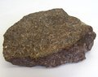Andesite | 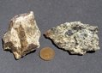Anorthosite | 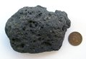Basalt | 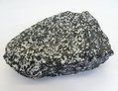Diorite | 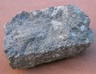Syenite
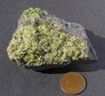Dunite | 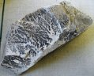Felsite | 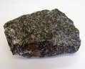Gabbro | 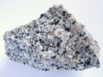Granite | 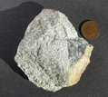Tonalite
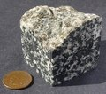Granodiorite | 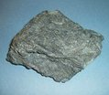Komatiite | 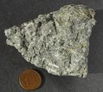Latite | 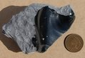Obsidian | 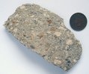Tuff
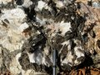Pegmatite | 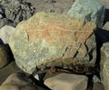Peridotite | 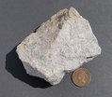Perlite | 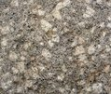Porphyry | 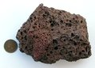Scoria
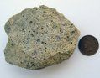Pumice | 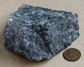Pyroxenite | 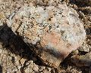Quartz Monzonite | 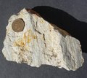Rhyolite

Sedimentary Rock Types
Sedimentary rocks form near the Earth's surface, wherever sediments can pile up and be gradually buried. The rocks in this gallery are arranged in order of their grain size: smooth chert through gritty sandstone to stony conglomerate.
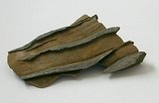  Shale and Sandstone |  | 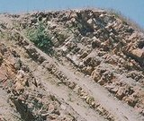  Chert and Mudstone |  | 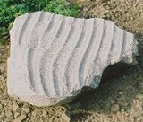 Siltstone
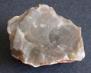Chert Nodule Interior | 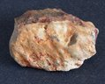Chert Nodule Exterior |  | 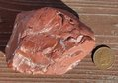Red Chert |  | 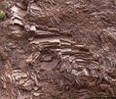Radiolarian Chert | 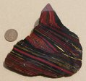Banded Iron Formation
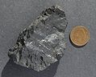Bituminous Coal | 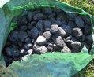Anthracite Coal |  | 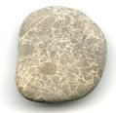Mudstone Breccia |  | 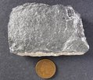Limestone |  | 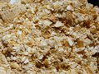Coquina
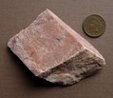Dolomite | 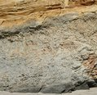Shale, Pleistocene |  | 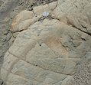Shale, Cretaceous |  | 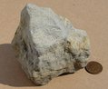Siltstone |  | 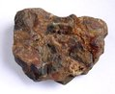Conglomerate
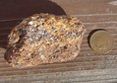Sandstone, Pleistocene | 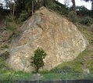Sandstone in Outcrop |  | 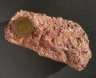Arkose |  | 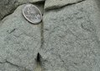Graywacke, Franciscan |  | 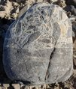Limestone Breccia
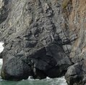Graywacke Outcrop | 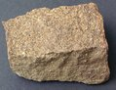Great Valley Graywacke |  | 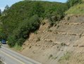Turbidites |  | 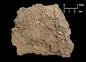Florida Peat

Metamorphic Rock Types

Metamorphic rocks are those that form by the effects of heat, pressure and shear upon igneous and sedimentary
rocks. Some form during mountain-building by forces of regional metamorphism, others from the heat of
igneous intrusions in contact metamorphism. A third category forms by the mechanical forces of fault
movements: cataclasis and mylonitization.

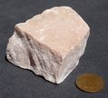Marble | 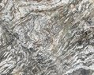Migmatite | 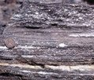Mylonite
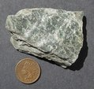Phyllite | 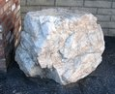Serpentinite | 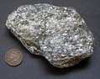Schist
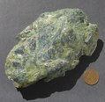Serpentinite | 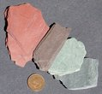Slate | 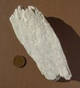Soapstone

