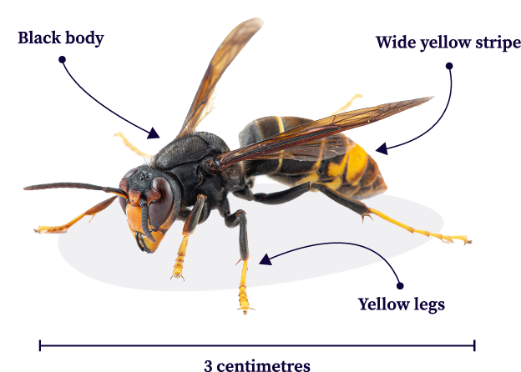
The Yellow-Legged Peril

Recently a new insect has been found that is causing serious concern as it preys upon honey bees and can give us a nasty sting too.

The Asian hornet is also known as the yellow-legged hornet. Like other insects in the wasp family, it has bright yellow bands on its black body and this one also has an orange head.

These insects build communal nests by chewing wood to make a papery pulp. Nests are found hanging from buildings or trees. Each nest is ruled by a queen who is surrounded by workers. In the tropics, where these insects come from, nests survive year-round. In a temperate country like NZ the nest will die over winter, with the lone queen hibernating in material to keep her warm like leaf litter.

The Asian hornet is invasive. This means that it comes from somewhere else, it hurts other living things and it spreads quickly. And this invasive insect is a problem because it threatens biodiversity and pollinators (and us!).

The Asian Hornet is an aggressive predator, mainly eating honey bees and other pollinators. It will catch bees in flight, kill them with its sting and take them back to their own nest. It can also rob eggs and larvae from beehives to feed their own larvae. Asian hornets have destroyed up to 30% of the bee colonies in other countries. For an agricultural country like NZ, this insect is a huge threat because we rely on bees to pollinate our crops so fruit and many veges will grow.

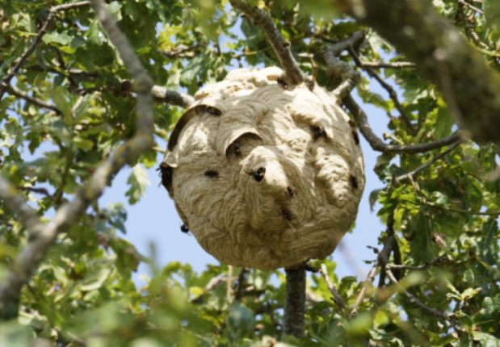
How is biodiversity threatened? Plants and animals live in ecosystems, interacting with each other and their environment. They live together in a delicate balance, so killing a group of living things will have effects on other parts of that system. We have seen the effect of rats and possums on the NZ bush and small insects are no different, they will have an impact too, on a different ecosystem. On top of that, our native animals have not lived with wasps and hornets before they were introduced here so have no natural defences against them.

Like their yellowjacket cousins, Asian hornets have a nasty sting which can pierce bee-keeping suits. In some people, their sting can cause anaphylactic shock, which is life-threatening.

These new invaders have been found on the North Shore in Auckland. The key to stopping Asian hornets from settling in here is to act early, while there are still just a few and they are in in a small area. So, in response, MPI is destroying nests, setting traps, and have people on the ground looking for the hornets. The scientists need our help too. if you see a wasp with yellow legs or a nest, report it to 0800 809 966 or https://report.mpi.govt.nz/pest/ . If you can do so safely, take a photo but don’t get too close.

Sources:
https://en.wikipedia.org/wiki/Hornet and https://theconversation.com/a-deadly-european-hornet-has-reached-nz-we-can-all-help-stop-its-spread-268874
Images https://www.kennet-beekeepers.co.uk/asian-hornet/
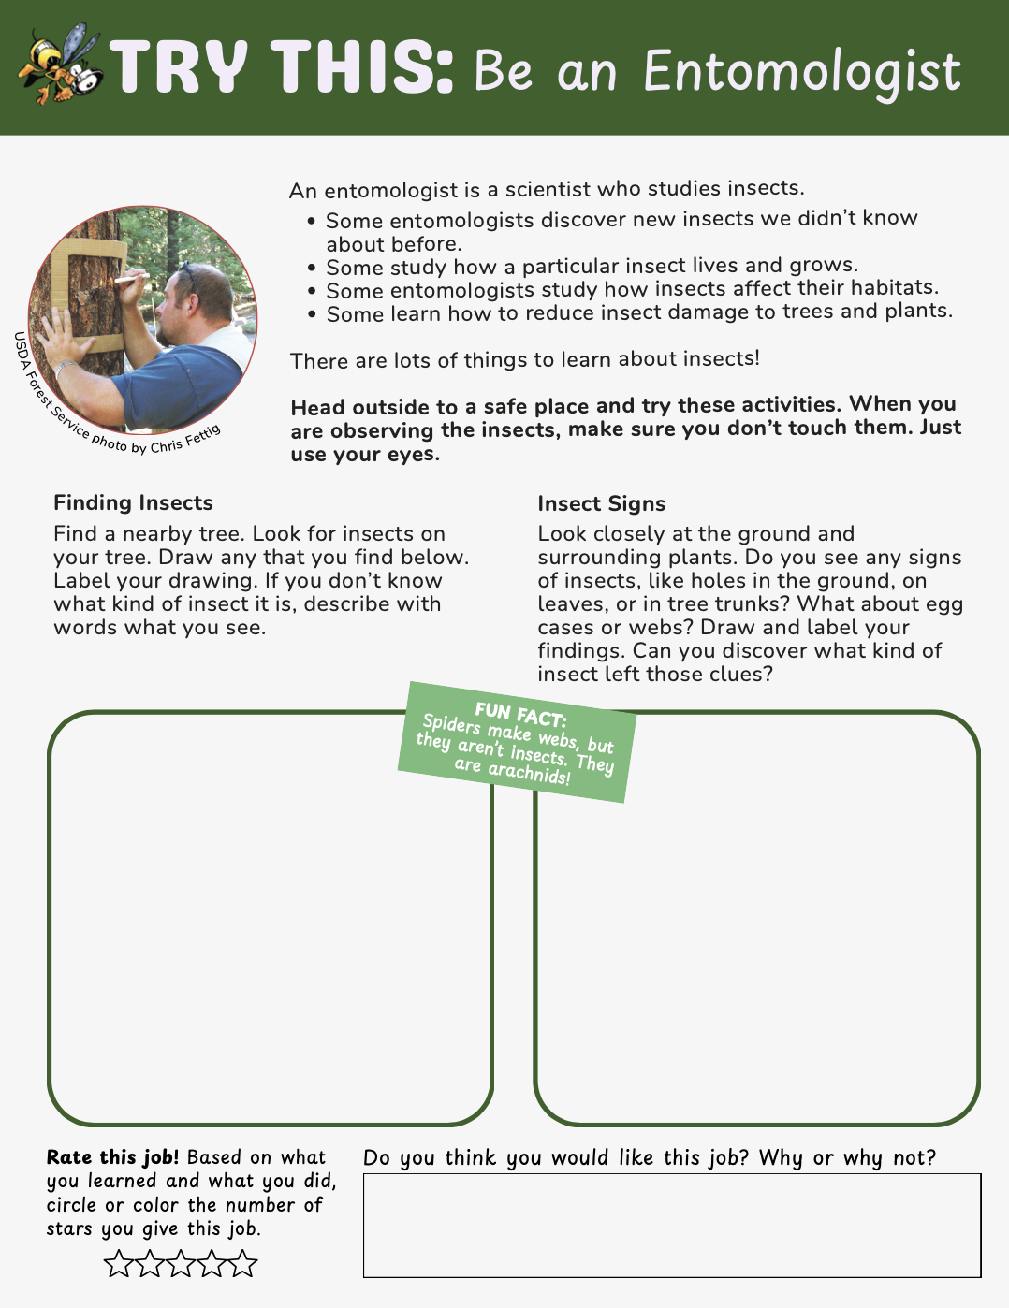

Activity from https://naturalinquirer.org/resource/woolly-watchers-spotting-forest-invaders/

