The 7 parts of Māori summer everyone should know
I first learned that matiti/Māori summer works differently to Pākehā summer when I was studying reo Māori at AUT. My kaiako/teacher explained that rather than seeing the season as one big chunk, a Māori view divides it into seven distinct kaupeka/parts or ‘mini-seasons’.
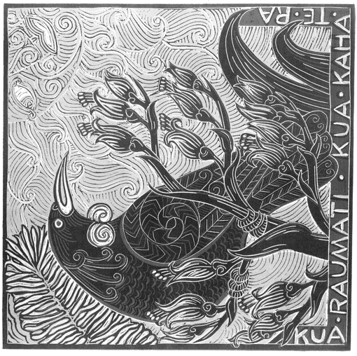
These kaupeka arrive not by gregorian schedule but through tohu/signs in te taiao/the environment. This means they naturally shift with our āhuarangi/climate, are super regionally specific, and in my opinion, way more helpful for understanding the natural world than four inflexible quarters.
The lesson stands out in my memory, not only for the mātauranga itself but my realisation that western concepts of season and time that I was used to were exactly that – concepts – with an array of local alternatives
I’m Māori, Austrian, Rarotongan, English, Scottish. I kinda got multiculturalism from the get-go but STILL, the Pākehā notion of time felt so concrete, so immovable, that this seasonal insight really did change my life.
Now, do I 100% remember the names and markers of said life-changing kaupeka?
Kāo/Nope. (Sorry Kururangi!)
Nō reira/And so this wiki, on a particularly sunny day, when I particularly felt like avoiding politics and the forecasting spreadsheet on my to do list, I dove into my notes for a refresh. Here they are for anyone else interested:
The 7 kaupeka of summer
(of course the whole point is that they vary but here’s a start)
Matiti Kura - the pīpīwharauroa/shining cuckoo is calling and bright red berries of the kahikatea or tōtara ripening. Whitebait are starting to run.
Matiti Hana - the temp is rising, blooming puawananga flowers cast a brilliant white over the ngāhere/forest, and tūī are out and about in a big way.
Matiti Muramura - the whetū/star, Rehua, rises directly into the sun. That white ngāhere is now turning red as the rātā and older pōhutukawa start to flower.
Matiti Kaiwai - the ground is super dry and showing cracks.
Matiti Raurehu - a subtle white dust-like substance on the lawn resembles frost (but obvs isn’t).
Matiti Rautapata - seed pods are bursting all over the show and littering their contents onto the dry leaf bed below.
Matiti Rauangina - leaves are falling from trees in a rhythmic dance known as te angina/the free fall.
Study ‘em, get excited thinking of all the books you’re gonna devour and mereni wai/watermelon you’re gonna eat and swims you’re gonna have in the midst of em, and remember ‘em.

Written by Lizzie Dunn who write a regular newsletter https://www.tearawhataaotearoa.com/

