Pruning Tomatoes

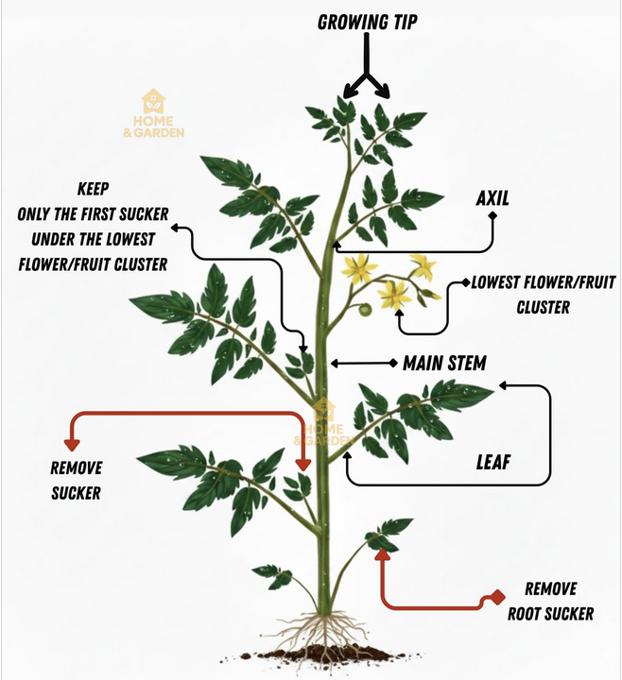

The one sucker that’s kept becomes a strong second stem and boosts yield without turning the plant into a jungle. Pruning all other suckers improves airflow, and reduces disease. The plant can then expend its energy on fruit instead of excess foliage. Prune in the morning on a dry day; avoid right after rain.

