Tricky Tracks

Teachers Notes:

Objectives
- To help students distinguish between observation and inference
- To introduce the concept that all ideas are valid until further evidence suggests otherwise.

Context
This activity is appropriate for students in any teaching sequence where observations & inference will be important. A possible follow up activity might be a series of activities which require careful observation and then interpretation – chemical reactions, video clips of animal behaviour, physical phenomenon.

Teaching overview
This activity can be carried out with the whole class or in small groups or as a think – pair-share activity.
This will require projected images if whole class or handouts for groups (all given image 1, they come up and get 2, then 3 when ready). It is important they only see 1 at a time.
Take your time. This can last 15mins but the students will get more out of it if it lasts longer, 30-40 mins

Possible Teaching Sequence
- Check student understanding of these key terms
- An observation is what we can see (or detect with any of our 5 senses – or instruments)
- An inference is an interpretation of what we see
- Put the first image in front of students
Ask: “What do you observe?” Remind them of what an observation is if necessary
At the start, students will often give inferences as observations. It’s really important to get the distinction right at this step. (eg 2 sets of converging marks is an observation, 2 birds walking towards each other is an inference). Encourage students to look for more than 1 idea. Leave them looking for a while and see if there are any other responses.
Once you have a collection of observations. Then ask, “what do you infer?”
- Put image 2 in front of students. Same questions – what do you observe? What do you infer?
- Put image 3 in front of students. Same questions – what do you observe? What do you infer?
- At the end:
- Our inferences have made some assumptions – can the students see them?
- Yes, the tracks could be interpreted as bird prints, but they could also be dinosaur prints
- We have also assumed the 2 sets of prints were made at the same time.
- Lots of different interpretations, all of them are valid. Why?
- How could we find out more?
- What does this activity teach us about the practices of science?

[FYI only: Observations may include – 2 sets of marks, pointing in the same direction, one set bigger than the other, 14 big & 34 small, each 3 lines coming from a blob, large ones further apart at the end. Inferences may include predator/prey, male/female, mother/young and fighting/eating, mating, picking up young, 1 climbing a tree, 1 flying away … .
E4: Scientists put forward ideas/theories to try to explain the things they see happening in the world. All ideas are valid until further evidence suggests otherwise They test these ideas with experiments. Sometimes new ideas come along which do not fit the old ideas. More experiments need to be carried out to see if the new idea is correct.”]

Images

Image 1

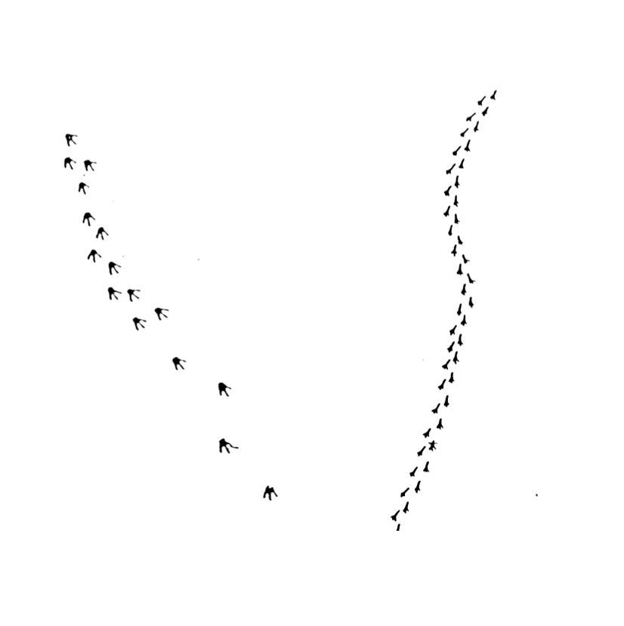

Image 2

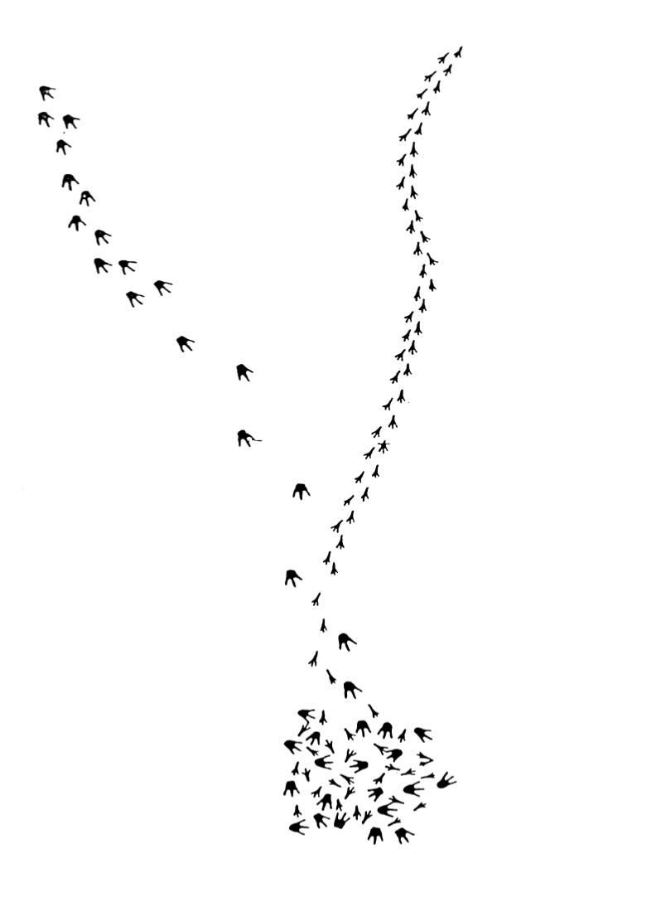

Image 3

