Waikato farmer breeds low-methane sheep to cut emissions and ‘solve problems’
RNZ 3 Nov 2025 Text & photos by Gianina Schwanecke

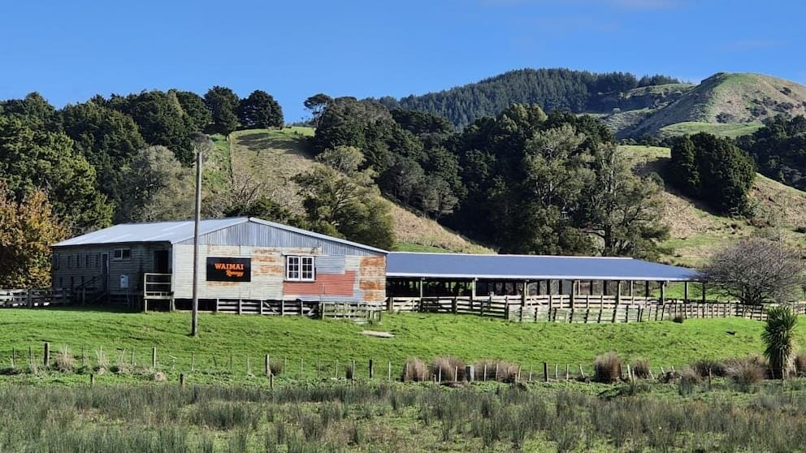
Set on 800 hectares in the Waimai Valley, north of Raglan, four generations of the Reeves family have farmed this land.
Alastair Reeves’ father taught him that farmers can use genetics to solve problems.
The Waimai Valley farmer is carrying on the line of Romney sheep his father started breeding in the 1950s. “They’re still here probably because they are fit for purpose,” he told RNZ’s Country Life. “They suit our environment, they’re hardy, they produce meat, they produce wool, and that’s essentially what’s paid the bills over the last six years, so that’s a testament to the breeders that have gone before us,”
But Reeves has also turned his eye to new sheep traits sought after by the modern farmer. He and his wife Ann run the 800-hectare farm, finishing bull beef and running a sheep genetics business. Their children are the fourth generation on this bit of whenua, north of Raglan.
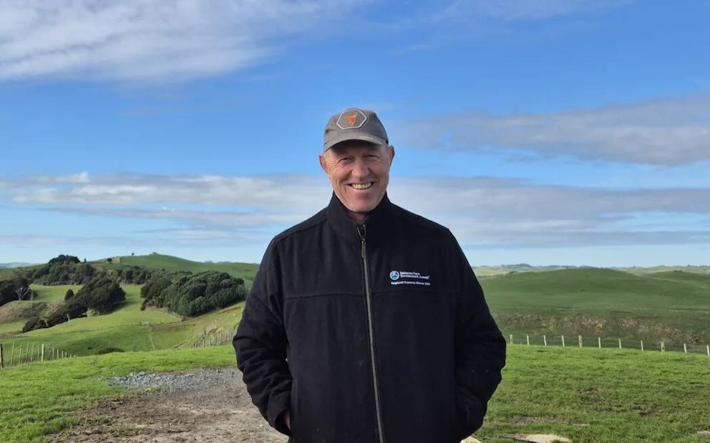
“Dad had a huge focus on eczema tolerance. He was one of the first breeders to start doing that. That was just an issue within Waikato and the Upper North Island; that’s just spreading down the country now.What we learned with the whole eczema trait is that genetics can actually solve problems.”
Another trait he’s begun breeding for is low methane – a greenhouse gas produced in the rumen, part of the four-chambered stomach of ruminant animals like sheep and cattle.
Alastair Reeves, of Waimai Romney
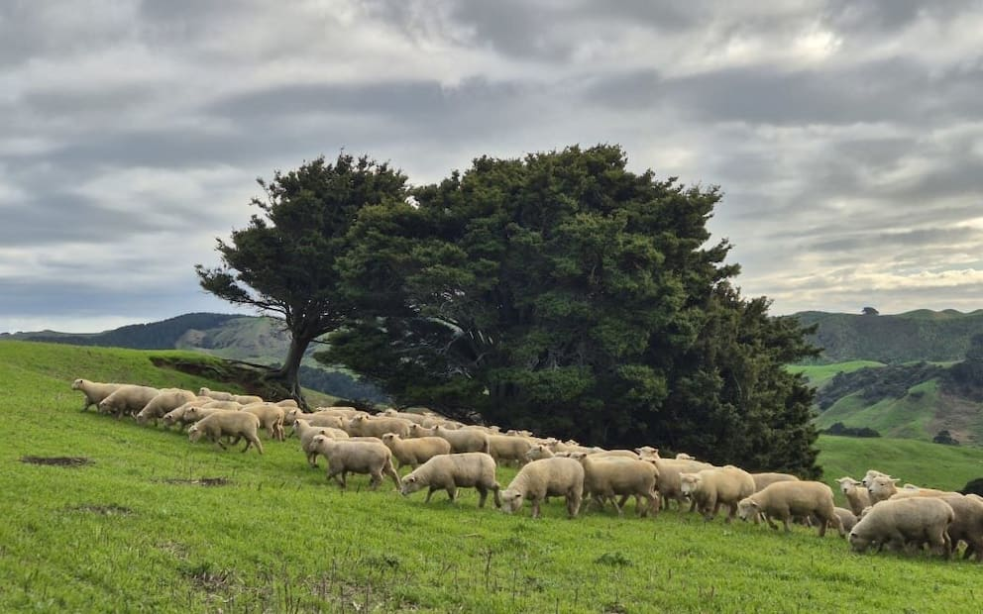
Reeves said methane emissions are a complex issue facing the sector.
“All I know as a geneticist is I’m here to produce the best genetics for my clients. I want those genetics to make them as profitable as they can receive.”
While methane reduction boluses and vaccines are in development, Reeves sees these as another ongoing expense for farmers. Genetics is a “green way” of mitigating the impacts of methane, but one that he says takes time. “If we can reduce the methane and at the same time improve the productivity of our livestock, that would be a really positive thing, and so that’s what we’re trying to do.”
Alastair and his wife Ann breed two types of sheep - the classic New Zealand Romney, and another breed they developed themselves, the Waimai CharaBlack.
In 2020, Waimai Romney became one of the first flocks in New Zealand to methane test its rams, running 192 rams through AgResearch’s Portable Accumulation Chamber (PAC) trailer. Since then, they’ve cut methane emissions by 3.2% while improving productivity.
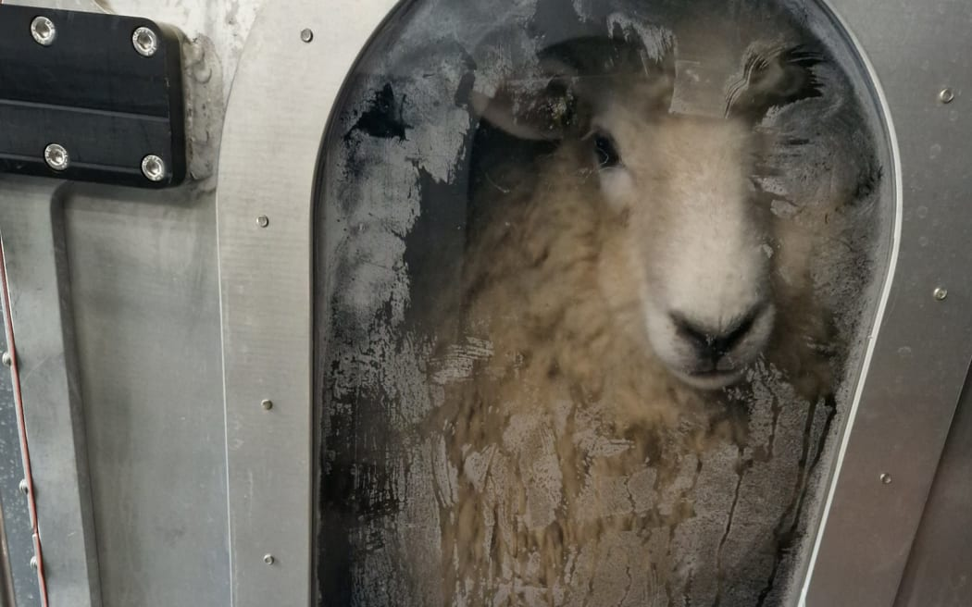
Over the past 10 years, they’ve also been developing their own breed – the Waimai Charablack. It’s a mix of the French Charolais – which has good marbling and makes “lovely” eating – and the Hampshire, an “old traditional breed”. They’ve focused on good growth as well as a good “marbled lamb product” equivalent to the “wagyu of lamb”. Alastair said this meant farmers could get premium prices, adding value to the same quantity of lambs.

Reeves said there had been a lot of changes on-farm since his father and grandfather’s day.
A sheep being tested in a methane detection chamber

It had been a tough couple of years for the sector, with farmland being converted to forestry, putting pressure on rural communities, especially hill country and sheep farmers. But there were positive signs too, with wool prices improving and strong global demand for protein, and in spite of the challenges, Reeves still loves what he does. And last year, the farm was named the Waikato Regional Supreme Winner at the Ballance Farm Environment Awards.
“It’s a phenomenal product. It’s grass-fed, and the world wants it.”

https://www.nzherald.co.nz/nz/waikato-farmer-breeds-lowmethane-sheep-to-cut-emissions-and-solve-problems/JRW7DKJQ4ZAVFABOBAAOCGE3PQ

