What are vitamins?
These nutrients found in foods help keep our bodies healthy
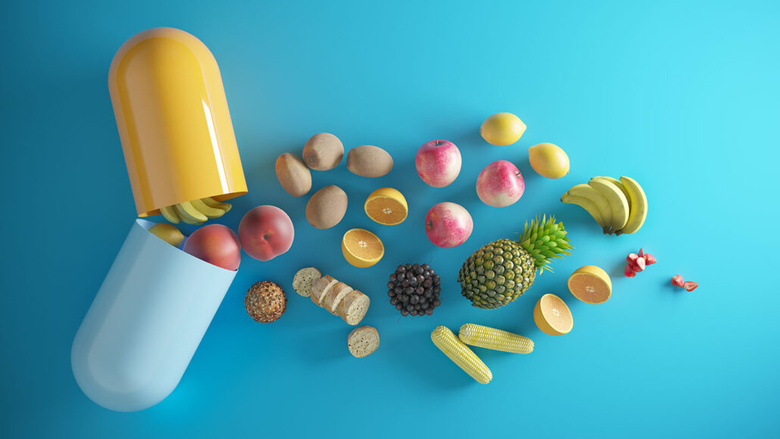
If you were asked to choose a healthy snack, what would it be? Perhaps you’d opt for a tangy mango or cup of tart Greek yogurt topped with berries. Maybe crunchy broccoli florets with hummus comes to mind. These are all packed with nutrients — chemical substances that help our bodies function. Among those nutrients are traces of vitamins.
Pills or foods? [Eoneren/iStock/Getty Images Plus]
Food scientists group vitamins and minerals together as micronutrients. That’s because living things need these to survive — but only in tiny amounts. While both vitamins and minerals are essential, chemically they’re quite different.

Vitamins and Minerals compared
Dietary minerals are elements that appear in soil and water. The minerals we need to know about include calcium, phosphorus, iron and iodine. Sodium, which we get in salt, is important too.
Vitamins, in contrast, are molecules — made of several elements. Vitamins are also organic, meaning they contain the element carbon.
Altogether, we need 13 vitamins to stay healthy. Eight are known as B vitamins. Rounding out the list are vitamins A, C, D, E and K. These all play essential roles in keeping our organs, tissues and cells working.
Some, such as the B vitamins, help the body break down and release energy from food. Vitamin K allows our blood to clot. Vitamin A is important for our lungs, skin and eyes.
Vitamin D is a pro-hormone. The kidneys turn it into a fully active hormone. And it’s quite versatile. This hormone plays a pivotal role in building strong bones and muscles and protecting the body from diseases, including some cancers. This vitamin also helps fight infections.
Plants absorb minerals with water in their roots and build them into plant tissues. But animals cannot make most minerals or vitamins, and so must get them in their diet, ie. in the plants or animals they eat. And this is true for us too, to get these essential substances we need to ensure they are in what we eat.

What are oxidants and antioxidants?
Other vitamins (such as C and E) are antioxidants. They help protect against unstable molecules. At high levels, such molecules, called radicals, can damage cells and DNA.
Vitamin C also supports your immune system in various ways. For instance, it helps keep immune cells healthy. But vitamin C also helps create collagen. A protein, collagen serves as a building block for many tissues, including our skin and the lining of our respiratory system. Those organs act as early lines of defence against incoming germs, explains Evangeline Mantzioris. She directs nutrition and food science at the University of South Australia in Adelaide.
By keeping these systems healthy, vitamins help our bodies fight germs, limiting their chance of causing serious disease. Clearly, Mantzioris says, vitamins don’t just target one specific body function or organ. They make sure our bodies as a whole work as they should.

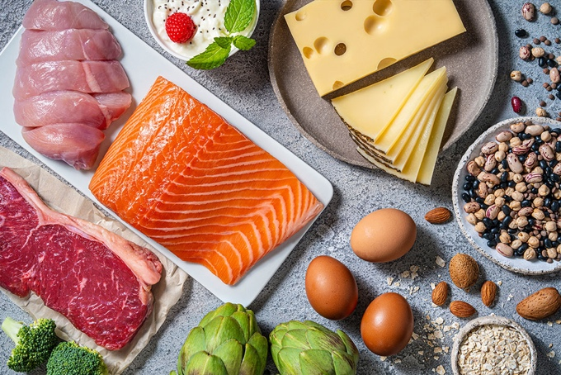
Water-soluble versus fat-soluble types
Vitamins fall into two general categories: water-soluble and fat-soluble.
Most vitamins dissolve easily in water. That means they can be found in such body fluids as blood. These vitamins include all eight B types and vitamin C.
“We tend to find the water-soluble vitamins in fruits and vegetables,” says Mantzioris. These are “foods that don’t have a lot of fat.” Our bodies don’t usually store any excess of water-soluble vitamins. Instead, unused amounts get flushed out in our urine.
Fat-soluble vitamins: Dairy products, seeds, eggs & meats are rich in not only protein but also vitamins A, D & E. For vitamin K, reach for broccoli & other green (& often leafy) vegetables, beans, avocados, vegetable oils & some meats. [MEDITERRANEAN/E+/Getty Images Plus]
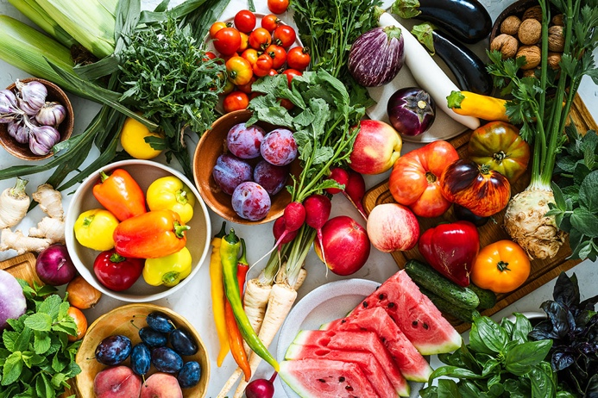
Fat-soluble vitamins (A, D, E and K) tend to show up in fatty foods. In fact, that fat helps our bodies better absorb these nutrients. Our liver and body will store any extra of these vitamins that we might consume until they’re needed later. “Even if we’re really lean, we still have a little bit of a fat stored in our body,” says Mantzioris.
The fat-soluble group also includes the two vitamins that people can produce: vitamins D and K. Bacteria in our intestines can make vitamin K.
Vitamin D is special. Known as the sunshine vitamin, our skin starts a process of making it by using the sun’s ultraviolet light. Today, most people lack ideal amounts. One reason: Covering up the body too much when in the sun. Sunscreen helps protect against skin cancers but limits vitamin D production. So does spending most of the daylight hours indoors. Darkly pigmented skin and very heavy cloud cover can limit exposure to the UV light that kick-starts vitamin D production. So can living at high latitudes, where a steep path through the atmosphere can filter out much of the sun’s ultraviolet light.
Fruit and veges are our diet’s primary sources of water-soluble vitamins — the eight B types and vitamin C. [istetiana/Moment/Getty Images Plus]

What’s the best way to get vitamins?
Most of the vitamins we need can be found in the foods we eat. While fruit and veges are well-known for being rich in vitamins, meat and grains contain these essential nutrients, too.
Vitamins are also available as food supplements sold widely in stores and over the internet. Many are synthetic preparations; others come from plant or animal sources. Some products may include single vitamins. Others may contain a blend meant to meet our daily needs.
But for most of us who eat a balanced diet and get enough sunlight, these products are unnecessary. Instead, focus on eating a healthy diet that includes plenty of produce. Notes Mantzioris, “We didn’t evolve on supplements. We evolved on whole food.”
Whole foods contain more than just vitamins. For instance, oranges are an excellent source of vitamin C. But these and other types of fresh produce also contain hundreds of other nutrients that aren’t found in artificial supplements, Mantzioris points out. These include plant compounds called phytonutrients. Such compounds give many fruits and veggies their vibrant colours. Scientists suspect they also boost health and fight disease. And new ones are still being discovered.
Supplements can be useful, though. People with certain medical conditions may need help getting enough of some vitamins. And it’s hard to reach the recommended amount of vitamin D through food alone. Vitamin D supplements may help those with heavily pigmented skin or whose skin doesn’t get access to enough of the sun’s UV rays. But these supplements should only be taken after talking with your doctor, says Mantzioris, because mixing vitamin supplements with certain medications can be risky.
It is important to get enough vitamins and minerals in our diet or else we can get deficiency diseases, eg.:
Pellagra    Scaley skin in sun-exposed areas | Rickets    Weak, soft bones | Scurvy    Captain Cook was the first to feed his sailors lemons to prevent scurvy on long voyages. | Goitre    Swollen thyroid gland

Can you consume too many vitamins?
Some vitamins, such as A, can be toxic when taken in high amounts. But poisoning is highly unlikely to happen when they’re consumed as part of a balanced diet. Most people who consume too many vitamins do so by taking supplements.
Taking too many supplements also risks flooding the body with more nutrients than it can handle. Fat-soluble vitamins can build up in our fat stores over time, leading to dangerous side effects. Even overdosing on some water-soluble vitamins can pose problems.
Cases of poisoning from water-soluble vitamin B6, for instance, are on the rise, notes Mantzioris. In addition to supplements, this nutrient is often added to energy drinks, weight-loss shakes and certain food products. One symptom of too much B6 is nerve damage. It often starts as a tingling in the fingers and toes. “If it’s not caught in time, it can cause permanent damage,” Mantzioris says.
Instead of splurging on supplements, Mantzioris recommends that people looking to stay healthy should focus on a food-first approach. “People spend a lot of money on these [vitamin supplements] — and mostly without a lot of gain,” says Mantzioris. “I would rather spend the money on having really yummy food.”
Adapted from Science News Explores Vitamins https://www.snexplores.org/article/what-are-vitamins

