How do we tell them apart?

Feature | Ship Rat (aka black rat) | Norway Rat (aka brown rat) | Kiore (aka Pacific rat)
Size | Smaller than Norway rat | Largest of the three | Smallest of the three
Tail | Long, thin, and longer than its body | Thick and shorter than its body | Same length or slightly shorter than its body
Ears | Large and rounded; cover the eyes when pressed forward | Smaller; do not cover the eyes when pressed forward | Smaller; barely reach the eyes when pressed forward
Habitat | Forests, urban areas. Can climb trees | Urban areas, near water, and human activity; near people. Can swim | Restricted to some offshore islands and specific mainland areas
Baits | Prefer sweet fragrant baits eg peanut butter, apple, chocolate, walnuts | Prefer savoury, meaty, oily, fatty baits eg fish oil, cat food, mayonnaise | Prefer high protein, sweet smelling eg peanut butter, macadamia nuts, berries

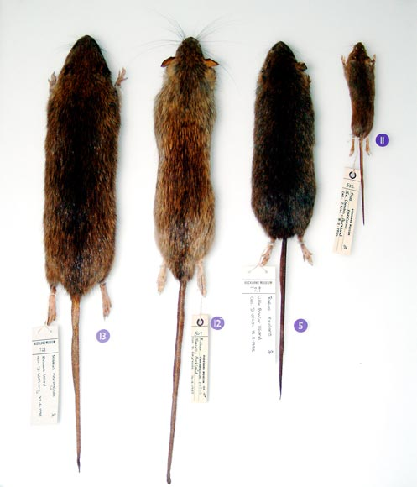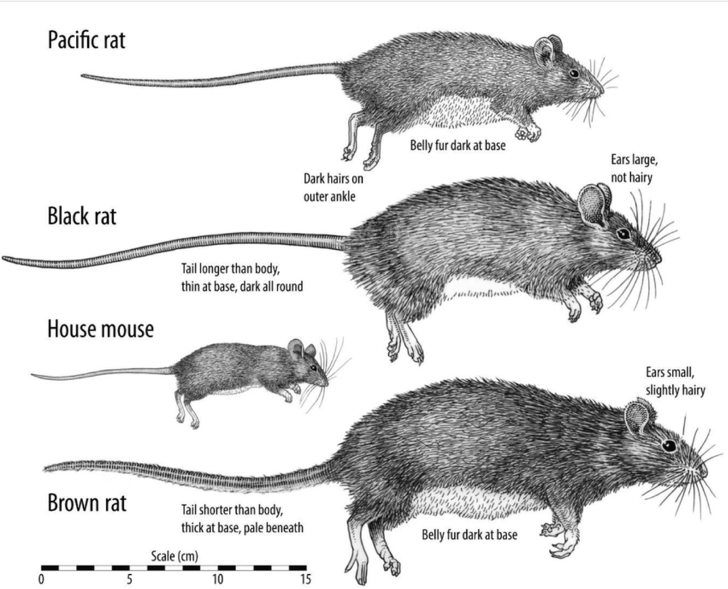
Top to bottom: mouse, kiore, ship rat, Norway rat

